# Budget Construction

## Introduction

The Budget Construction (BC) module of the Kuali Financials is a financial tool that allows your organization to construct the base budget for the coming fiscal year. It is used to designate a base fiscal commitment.

go-arrow-red.gif In order to work efficiently in the Budget Construction module, you need to understand the basics of the Kuali Financials user interface. For information and instructions on logging on and off, navigating, understanding the components of screens, and performing basic operations in the screens, see Overview|document=WordDocuments\FIN Overview Source.docx;topic=Overview. Overview and Introduction to the User Interface.

## Overview of Budget Construction

The Budget Construction module is a financial tool that allows your organization to construct the base budget for the coming fiscal year. It is used to designate a base fiscal commitment.

The Budget Construction module differs from other Kuali Financials modules in that users do not initiate the Budget Construction (BC) documents. Instead, Budget Construction Documents for existing accounts are created by the batch job that is run once a year. Users may create a new document if one has not already been loaded as a result of the one-time batch load (Genesis) or the nightly batch updates. In either case Budget Construction Documents do not route for approval.

To retrieve a Budget Construction Document, you access it from the Budget Construction Selection screen. This screen provides quick access to several different functions via buttons.

The Budget Construction Document sets budgets in whole dollars.

In Budget Construction, routing is called 'pull-up' and 'push-down' and is controlled by users assigned to the BC Processors roles. BC processors move the documents along the organization hierarchy defined in the chart of accounts. What any specific user can do with the document depends upon where it is in the hierarchy and the pre-defined locking rules.

### Budget Construction Screens

The Budget Construction module includes a variety of screens that are available from the navigation buttons on the Budget Construction Selection document.

Budget Construction screens

|  |  |
| --- | --- |
| Document/Screen | Description |
| Budget Construction | Allows you to quickly perform budget construction tasks such as editing the revenue or expenditure accounting line details, viewing online reports, and exporting the budget data. |
| Budget Construction Selection | Provides a central point of control in the BC process. Its primary function is to open an existing Budget Construction Document or create a new one. |
| Document Reports and Exports | Allows you to access account- or organization-based reports and export budget data. |
| Lock Monitor | Allows the root-level approver (top level organization hierarchy) to release documents with hung locks. |
| Pay Rate Import / Export | Helps a root-level approver set the hourly pay rate of biweekly paid incumbents associated with a particular bargaining unit (union). |
| Quick Salary Setting | Used to quickly set salaries for existing funding lines associated with positions and incumbents in a particular accounting line for an account or sub-account. |
| Salary Setting by Incumbent | Allows you to set (add or modify) salaries for existing funding lines associated with positions in a particular accounting line for an account or sub-account from the incumbent perspective. |
| Salary Setting by Position | Allows you to set (add or modify) salaries for existing funding lines associated with incumbents in a particular accounting line for an account or sub-account from the position perspective. |

### Budget Construction Tables

The Budget Construction module requires a set of reference tables and payroll tables that are necessary to build next year’s budget. Each implementing institutions must determine how it is going to update the tables. These tables include the following.

Reference and payroll tables used for budget construction

|  |  |  |
| --- | --- | --- |
| Table | Description | Update Method |
| Account Reports | Maps each account to its reporting organization for the fiscal year currently being budgeted. | Created by the Genesis job initially; changes are managed via maintenance document. |
| Appointment Funding Duration | Used in the budget construction salary setting process to identify the duration of leaves from work (sabbaticals, leaves without pay, etc).  pencil-small The delivered set of funding duration codes are meant to be used by implementing institutions. They can be changed but changes require the application logic to be changed also. | Standard codes are delivered with the application; changes are managed via a maintenance document. |
| Appointment Funding Reason Code | Used in the budget construction salary setting process to indicate the reason for a particular salary increase.  pencil-small The delivered set of funding duration codes are meant to be used by implementing institutions, but no validation rules depend on the set and could be changed without adversely affecting the application. | Standard codes are delivered with the application; changes are managed via maintenance document. |
| Budget Construction Position | Allows you to view position information. If your institution chooses not to feed position information automatically from an external payroll system, this screen also allows you to look up, create, and modify existing positions included in a budget. | The table may be created and updated automatically from your institution's HR/payroll system (customization is required) or may be maintained via maintenance document. |
| Calculated Salary Foundation Table | Tracks the funding changes for each appointment in the payroll system; identifies the accounting keys (chart, account, sub-account, object, and sub-object) that fund the position. | Your institution must populate this table from its HR/payroll system. |
| Calculated Salary Foundation Tracker Override | Allows you to override data contained in the Labor Distribution Calculated Salary Foundation Tracker table.  pencil-small Overrides are applied from CSF Tracker Override to CSF Tracker as the last step in the process that updates the Budget Construction CSF Tracker table. | Manually maintained via a maintenance document. |
| Intended Incumbent | Allows you to view or update incumbent information. | May be automatically updated from the institution's HR/payroll system (requires customization) or manually updated via a maintenance document. |
| Organization Reports | Maps each organization to its reporting organization for the fiscal year currently being budgeted. | Created by the Genesis job initially; changes are managed via a maintenance document. |
| Admin Post | An optional table for informational purposes only. | Your institution must populate the table. |

### Tables Shared with Other Modules

Since Budget Construction combines base budget data from the General Ledger and position and incumbent data from your institution's payroll system, it shares tables with the Labor Distribution module. Additionally, some Budget Construction functionality is controlled by the Function Control table, which is shared by the Budget Adjustment document within the Financial Processing module.

Shared tables

|  |  |  |
| --- | --- | --- |
| Table | Description | Module |
| Labor Object Code Benefits|document=WordDocuments\FIN LD Source.docx;topic=Labor Object Code Benefits Labor Object Code Benefits | Stores fringe rates to calculate benefit budget. | Labor Distribution |
| Labor Object Codes|document=WordDocuments\FIN LD Source.docx;topic=Labor Object Code Labor Object Code | Signals the system that the budget line is salary related. | Labor Distribution |

### Calculated Salary Foundation

The Calculated Salary Foundation (CSF) table contains appointment data that normally represents a portion of the ongoing salary commitment for an incumbent in a position that is funded out of a particular account, sub-account, object and sub-object. Positions that are vacant can still be associated with committed funds.

The Genesis batch process (discussed below) uses information in the CSF table to populate the Budget Construction CSF table, the BC perimeter tables, and the salary-setting-related maintenance tables used in Budget Construction.

The overrides are applied by Genesis, which first gets the set of CSF rows, then applies the overrides and stores the results in the BC CSF table. So, your institution's version of the CSF tracker process should *not* need to apply the overrides during the build of the regular CSF table.

pencil-small **When to Override the CSF Tracker Table**: The base functionality overrides only the CSF table during the Genesis process. However, your institution should make a decision as to where it makes sense to see the result of the CSF Tracker overrides (in CSF or in BC CSF) and make modifications accordingly.

### Budget Construction Cycle

The Budget Construction cycle begins with the Genesis process. This process puts the initial data into the Budget Construction module from the General Ledger and the payroll system. Subsequently, parts of the Genesis program run once each day to add new data from GL transactions and payroll activities. Various parts of the batch budget update can be enabled or disabled using the Budget Function Control table.

go-arrow-red **About the Budget Function Control Table:** For information about function control codes, see Function Control Code|document=WordDocuments\FIN BC Source.docx;topic=Function Control Code.

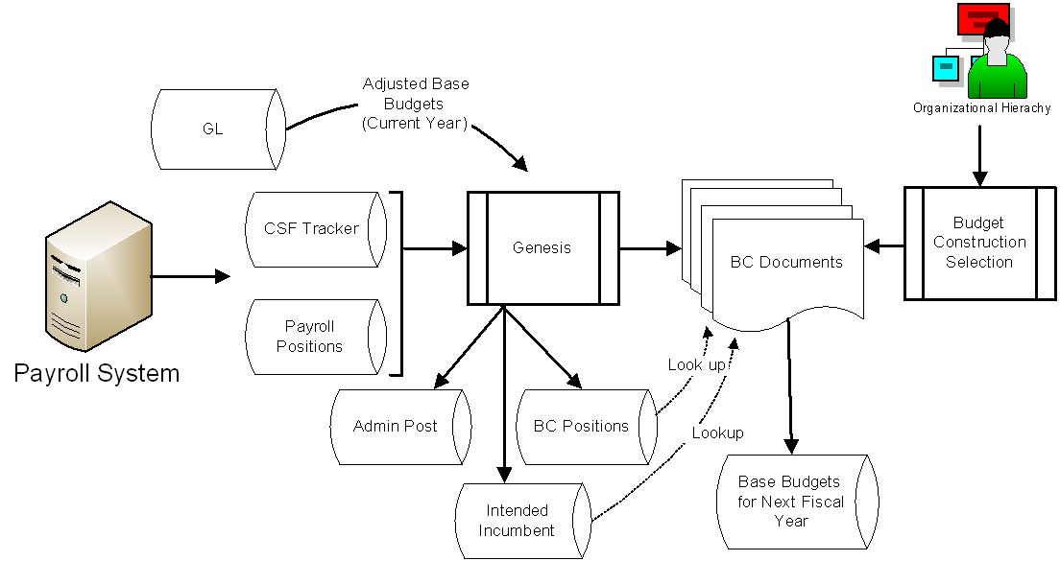

The BC update job keeps the data current within Budget Construction, with the GL, and with the payroll system until you set a flag to tell it not to. The BC update job does many of the same things that the Genesis job does except that it does not override data that has been changed by the users.

#### Feeding Base Budgets from BC to GL

The delivered Budget Construction General Ledger load process is run in batch after the budget is determined to be complete and has been verified using the various Budget Construction organization reports. The baseline budget is fed to GL with a document type of BC and balance types of BB (base budget) and CB (current budget). Balance type MB rows are also created if there are any monthly budgets in Budget Construction.

pencil-small **BUDGET CONSTRUCTION GL Load Process:** This job is not Scheduled because it is run only once a year. You need to request your system support staff to execute this job on the server. After the base budgets are loaded into Kuali Financials, you may view the base budget transactions from the General Ledger Pending Entry balance inquiry until the next run of the GL 'poster'. After the GL 'poster' is run, the transactions are in GL Entry (which also has an inquiry screen) and are posted to GL Balance.

### Budget Construction Tasks

The Budget Construction Selection screen is the hub of Budget Construction document operations. Using the buttons on this screen, you may perform various tasks such as:

* Listing the accounts for which you are the fiscal officer or delegate
* Setting salary by position or incumbent
* Generating budget reports
* Exporting or importing budget data
* Pulling up or pushing down Budget Construction Documents along the organizational tree
* Adding notes using the Notes & Attachments tab
* Importing (union) pay rates (root-level user only)
* Using the Request Import tool to import non-compensation object code related accounting lines

### Budget Construction Roles

Access to the Budget Construction documents is restricted. The following users are allowed to perform Budget Construction activities as indicated.

* The fiscal officer or delegate (for the Budget Construction Document type or the special value 'ALL') may prepare budgets for his/her accounts when the associated document is at level zero.
* Users in the Budget Construction Processors role may pull up the Budget Construction Document up to their own organization level and push it down to any level in the hierarchy below their approval level.
* The Budget Construction processor at the top level of the organization hierarchy may unlock the document and import pay rates.

#### Organization Hierarchy

Budget Construction tracks your security by the organization tree level. 0 is a leaf level where the fiscal officer is assigned. This is the lowest level of the hierarchy. From this level, various levels of Budget Construction Processors may be defined traversing the organizational chain up to the top level of the university.

As the Budget Construction Processor role is assigned to a user for a specific level within the organization hierarchy, the user's ability to view/edit, pull up, or push down the Budget Construction Documents is determined.

#### Levels

Organizational levels are built automatically from your chart of accounts based on the **Reports To** field in the Organization table. Each user of Budget Construction is placed somewhere in the organization hierarchy when the user's role is assigned. As soon as a user opens a document, his or her level is displayed in the Budget Construction Document, and this indicates how many levels he or she can pull up or push down the document.

For example, if the BL-1031400 account belongs to the Psychology (PSY) department, which reports to the Arts and Science School (ARSC), which reports to the Bloomington campus (BL), which ultimately reports to IN-UNIV (Indiana University), you may place Budget Construction processors at each level of the organization as shown in the organization tree on the right.

Then each Budget Construction processor can pull up and push down the Budget Construction Document for the levels they are assigned to.

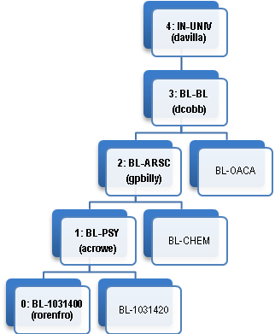

The following chart summarizes the activities each user shown in the figure above can perform based on the organization hierarchy.

User capabilities at each level of the sample organization

|  |  |  |  |
| --- | --- | --- | --- |
| Level | Description | Role | Actions |
| 0 | Account Level Update Access | Fiscal Officer or Account Delegate | Can use **my accounts**  Can update the budget for the accounts  Can use account reports  Can import non-compensation budget |
| 1 | BL-PSY: Psychology | BC Processor  (BL-PSY) | Can use **my organization**  Can pull up from Fiscal Officer.  Can import non-compensation budget  Can use organization reports |
| 2 | BL-ARSC: Arts and Science | BC Processor  (BL-ARSC) | Can use **my organization**  Can pull up from or push down to Fiscal Officer or BC Processors below this level.  Can import non-compensation budget  Can use organization reports |
| 3 | BL-BL: Bloomington Campus | BC Processor  (BL-BL) | Can use **my organization**  Can pull up from or push down to Fiscal Officer or BC Processors below this level.  Can import non-compensation budget  Can use organization reports |
| 4 | IU-UNIV: University Level | BC Processor  (IU-UNIV) | Can use **my organization**  Can pull up from or push down to Fiscal Officer or BC Processors below this level.  Can import non-compensation budget  Can use organization reports  Can unlock documents  Can load union pay rates |

### Budget Construction Security Model (Locking)

In Budget Construction, documents are locked by the users currently working with the document. Locks are set when a user gets edit access, either during the initial open of the document or during an account pull-up/push-down operation. Locks are released for documents in edit mode when closing a document or after pushdown to a level that puts the document in view mode. The daily Budget Construction Update job releases all existing locks nightly.

Special root approver users (users at the top level organization hierarchy) have the ability to perform the unlock action. There are four types of locks in Budget Construction.

* *Account Lock*: issued when a user displays a document in edit mode.
* *Funding Lock*: issued for accounts associated with the displayed funding lines where user has edit access, when using the Salary Setting by Position or Salary Setting by Incumbents screen.
* *Position Lock*: issued when a user either displays the Salary Setting by Position or the Salary Setting by Incumbent screen
* *Account Transaction Lock*: issued for each funding line when the user submits Salary Setting by Position/Incumbent change. This lock exists only during the time it takes to update the associated pending accounting lines contained in the Budget Construction Document for the account.

### Budget Construction Sessions

#### Timeout

Budget Construction handles web session timeout differently from the way other modules handle it. When you leave the screen idle beyond the web session timeout period, Budget Construction forces you back to Budget Construction Selection.

#### Session Cleanup

When you exit Budget Construction Documents without closing properly and try to return to the Budget Construction Selection, you will be asked to clean up the session. Click **yes** to proceed.

## Budget Construction Documents and Operations

When you select Budget Construction Selection, the system displays a menu of buttons that provides a central point of control in the budget construction process. From this point, users construct groups of income and expense accounts that create, in combination with other accounts, the financial plan for your organization.

### Budget Construction Selection

The **Budget Construction Selection** provides a central point of control in the budget construction process. After you choose this option, you may open an existing Budget Construction document or create a new one. Depending on your role and the associated organizational hierarchy, the number of operations available to you via buttons on the screen varies.

exclaim You may use this screen only if Budget Construction is active for one and only one fiscal year.

#### Budget Construction Document Open Section

The first action the user must take is to select an account and load the budget into the Budget Construction Document. There are three ways to accomplish this task:

* Selecting the chart and account directly in the Budget Construction Selection screen
* Using **my accounts**
* Using **my organization**

exclaim Anyone who has access to the document can directly enter the chart and account and load the budget. However, only users assigned to the Fiscal Officer or Budget Construction Processor roles in the organization hierarchy of the account are potentially granted edit capability.

##### My Accounts

My Accounts lists the account for which you are the fiscal officer or delegate (for the document types BC and ALL) and allows you to load the Budget Construction Document. Once the Budget Construction Document is loaded, you are able to view reports and manipulate revenue and expense budgets.

To access your account, click the **My Accounts** button.

The system creates your list from the current set of Budget Construction Documents for which you are the fiscal officer or delegate.

If you do not have any accounts for which you are the fiscal officer or delegate, the system displays this error message: “There are no budgeted accounts where you are the account's manager or delegate.”

##### My Organization

My Organization (List Accounts for My Organization) lists all Budget Construction Documents for which you are a Budget Construction Document approver in the review hierarchy.

1. To access your organizations, click the **My Organizations** button.

The system creates your list from the current set of Budget Construction Documents in which the account reports anywhere in the sub-tree of your approver organization.

1. On the Organization Selection screen, select organization(s) from the organization sub-tree.
2. If desired and if the **down** arrow is available in the Action column in the **Organization Sub-Tree** section, click the arrow to drill down into the organization.

The organization sub-tree expands as you click the down arrow.

Click the **up** arrow to return the previous level.

1. Select the organization and click the View button next to “Show Budgeted Accounts” in the **Selected Operation** tab.
2. From the Budget Construction Account Lookup, select the account to load.
3. Click the **Load Document** link under **Actions** to open the Budget Construction Document. You cannot edit the document unless the document displays “Edit access granted” in the top left corner.

#### BC Organization Salary Setting/Report/Control Section

The Budget Construction Organization Salary Setting/Report/Control Section offers various operations to BC processors who are approvers within the organization hierarchy.

###### Org Salary Settings

The **Org Salary Settings** button takes you to the Organization Selection screen where you may view salary data. This screen is designed so that any number of BC processors can work on salary setting all at once. This screen is especially helpful for managing split funded positions. The screen looks much like the My Organization screen except that the operations are geared toward managing salary data as opposed to loading the Budget Construction Document.

Near the bottom of the screen, the Show Position Pick List option takes you to the Position Select Lookup and then to the Salary Setting by Position screen. The Show Incumbent Pick List option takes you to the Incumbent Select Lookup and then to the Salary Setting by Incumbent screen.

Show Position Pick List

To view the appointment data from the position perspective, use the Show Position Pick List option in the **Select Operation** tab. To do so:

1. Select the Organization Sub-Tree and click the **View** button next to Show Position Pick List.
2. Enter your select criteria and click the **Search** button.

pencil-small The **Extended** button expands the search option to the entire BC position or BC incumbent table, while the initial search screens return the subset associated with the selected organization(s). The **Posn Salset w/ sync** links becomes available when you click **extended**. The **extended** button is typically used to add new incumbents or positions that are not currently budgeted in the selected organization(s) sub-tree.

1. Click the Posn Salset link to select a position. The Salary Setting by Position screen opens.

go-arrow-red For information about using this screen, see Salary Setting by Position.|document=WordDocuments\FIN BC Source.docx;topic=Salary Setting by Position

Show Incumbent Pick List

To view the appointment data from the incumbent perspective, use the Show Incumbent Pick List option from the **Select Operation** tab. To do so:

1. Select the organization sub-tree and click the **View** button next to **Show Incumbent Pick List**.
2. Enter your search criteria and click the **Search** button.

The **Extended** button expands the search to the entire BC position or BC incumbent table, whereas the initial search screen returns the subset associated with selected organization(s). The **Incmbnt Salset w/ sync** link displays when you click the **Extended** button.

The **Extended** button is typically used to add new incumbents or positions that are not currently budgeted in the selected organization(s) sub-tree.

Click the **Incmbnt Salset** link to select a position and open the Salary Setting by Incumbent screen.

go-arrow-red For information about using this screen, see Salary Setting by Incumbent|tag=Salary_Setting_by_Incumbent.

###### Org Report/Dump

The **Org Report/Dump** button allows you to view various reports for analysis.

go-arrow-red For information on using these options, see Document Reports and Exports|document=WordDocuments\FIN BC Source.docx;topic=Document Reports and Exports.

###### Request Import Tool

This tool allows you to import budget request data for non-compensation object-code-related accounting lines in one or more Budget Construction Documents from a local data file. The tool operates under the security rules of the BC security model. Following are basic rules associated with the request import tool:

* The import file must be a csv or tab-delimited file.
* The import file must contain either annual request or monthly request amounts.
* The import tool inserts new, or overwrites existing, matching lines. Any monthly budgets for existing lines are deleted when importing annual budget amounts.
* Each line must be unique.
* A budget construction document must exist for the account or sub-account.
* The account or sub-account may not be expired.
* The account or sub-account and object code or sub-object codes must exist and be active in the chart for the budget fiscal year.

The default system provides two import templates you may want to use or modify—[BC_Annual_Request_Imports.xls](../NetHelp/WordDocuments/BC_Annual_Request_Imports.xls)[BC_Annual_Request_Imports.xls](https://kualico.atlassian.net/wiki/pages/viewpageattachments.action?pageId=1179698) and [BC_Monthly_Request_Imports.xls](../NetHelp/WordDocuments/BC_Monthly_Request_Imports.xls)[BC_Monthly_Request_Imports.xls](https://kualico.atlassian.net/wiki/pages/viewpageattachments.action?pageId=1179698).

The following images are import file format samples.

* Annual budget, no text field delimiter:

|  |
| --- |
| UA,1912201,,5000,,2000  UA,1912201,,5001,,1212  UA,1912201,,5002,,30  UA,1912201,,5002,FOO,200  UA,1912201,,5003,,333  UA,1912201,,5004,,444  UA,1912201,,5005,,555 |

* Monthly budget, no text field delimiter:

|  |
| --- |
| UA,1912201,,5000,,2012,2013,2012,2013,2012,2013,2012,2013,2012,2013,2012,2013  UA,1912201,,5001,,50,50,50,50,50,50,50,50,50,50,50,50  UA,1912201,,5002,,30,30,30,30,30,30,30,30,30,30,30,30  UA,1912201,,5002,FOO,205,200,205,200,205,205,200,205,200,205,200,205 |

* Annual budget with text field delimiter:

|  |
| --- |
| “UA” , ”1912201” , ”TTTTT” , ”5006” , ”” , 666  “UA” , ”1912201” , ”” , ”5007” , ”” ,777  “UA” , ”1912201” , ”NUTS” , ”5000” , ”” , 500  “UA” , ”1912202” , ”” , ”5000” , ”” , 500  “UA” , ”1912202” , ”” , “5001” , ”” , 400  “UA” , ”1912202” , ”” , 5002” , ”” , 303  “UA” , ”1912202” , ”” , 5003” , ”” , 222 |

Adding Annual Budget

To add an annual budget:

1. Click the **Request Import** button from the Budget Construction Selection screen.
2. Browse your desktop, select a file, set the file type, separator, and delimiter values, and click the **Submit** button. A pdf log file is created. View the log file to verify the file was processed successfully. If there are any errors in the file, they will be noted in the log file.
3. When you open the Budget Construction Document for the accounts updated in the file, the requested budget columns will be updated for the accepted records.

###### Lock Monitor

Lock monitor is a function that allows you to view existing locks held by users. The unlock action can be taken only by the root level approver, and the **unlock** button is displayed only to BC Processors at the top level of the organization hierarchy.

exclaim The release-locks functionality should be used judiciously. Clearing a lock could destroy a user's current editing session.

To release a lock, follow these steps:

1. Click the **Lock Monitor** button.
2. Click the **Unlock** button next to the record you want to unlock.
3. Click the **Yes** button when the warning is displayed.
4. A success message is returned for the record that was unlocked.

###### Importing/Exporting Pay Rates (“Union Load”)

Payrate Import/Export is a tool used to update salary rates for union member employees. Export creates a spreadsheet file containing the set of appointments associated with a particular union. The file is then updated, either through a manual or automated process, with the desired hourly rate based on the negotiated salary rates for the set of employees. You then import the adjusted file to update the annual request and hourly rate amounts in the BC Pending Appointment Funding table. This allows you to efficiently update the union worker's funding line at the last minute.

The **Payrate Import/Export** button appears only for the root level approver in the Budget Construction Organization **Salary Setting/Report/Control** section of the Budget Construction Selection screen.

pencil-small Any documents to be updated must not be locked. Additionally, the system must in edit mode.

Exporting pay rates

|  |  |
| --- | --- |
| Field | Description |
| CSF Freeze Date | A reference date indicating when the CSF annual rates were last updated. Usually this date corresponds with the date on which the CSFUPD flag in the Fiscal Year Function Control table was set to 'N', but it can be any date that helps determine the correct rate increase with respect to payroll synchronization timing issues. |
| Position Union Code | This is the value in the BC Position table field called Position Union Code. It allows the user to select/update a group of positions managed under a particular union contract. |

To export pay rates:

1. Click **Payrate Import/Export** button.
2. Enter the position union code and CSF freeze date and click the Submit button. The payrate file is downloaded to your desktop.

Importing Pay Rates

The file to be imported must be a 102-character-long text file formatted as shown in the following table.

Format of rows for importing pay rates

|  |  |  |  |
| --- | --- | --- | --- |
| Field | Start Position | Length | Description |
| Emplid | 1 | 11 | Employee ID |
| Position_nbr | 12 | 8 | Position number |
| Person_nm | 20 | 50 | Position name |
| Setid_salary | 70 | 5 | Set ID for salary |
| Sal_admin_plan | 75 | 4 | Salary admin plan |
| Grade | 79 | 3 | Grade |
| Union_cd | 82 | 3 | Union Code |
| Appt_rqst_pay_rt | 85 | 10 | Uses an implied decimal format with two decimal places to carry the cents. For example, $7.56 is represented as 756  Setting appt_rqst_pay_rt to -100 means there is no active job record for the combination of Emplid and Position_nbr |
| Csf_freeze_dt | 95 | 8 | CSF Freeze Date. The format is yyyymmdd |

----|----1----|----2----|----3----|----4----|----5----|----6----|----7----|----8----|----9----|----0--

0000001355000016955Micky Mouse IUBLASS 0A B1 000000089020091102

0000001360000015122Donald Duck IUBLASS 0F B1 000000105020091102

0000001369000017884Sleeping Beauty IUBLASS 0H B1 000000120020091102

0000001378000016324Peter Pan IUBLASS 0F B1 000000130020091102

To import a file, follow these steps:

1. Prepare the import file.
2. Check that budget construction updates are allowed.
3. Click the **Payrate Import/Export** button.
4. Browse your desktop, select the pay rate file, and click the **Submit** button. A pdf log file is generated. View the log file to verify the file was processed successfully. If there are any errors in the file, they will be noted in the log file.

###### Org Pull Up

The **org pull up** button takes you to the Organization Selection screen. On this screen you may pull up a subset of documents associated with the selected organization sub-tree(s) of the selected point-of-view organization to the point-of-view level.

To pull up documents, follow these steps:

1. Click the **Org Pull Up** button in the Budget Construction Selection screen.

The system displays the Organization Selection screen.

1. In the **Organization Sub-Tree** section, use the **down arrow** to expand the organization sub-tree.
2. Use the **Selected** list to select individual or global organization(s).
3. Choose from these options:

* **Set Org**: Operates on documents directly reporting to the selected organization.
* **Set Sub Org**: Operates on documents not directly reporting to the selected organization (all others in the sub-tree below the selected organization).
* **Set Org & Sub Org**: Operates on documents in both previously defined sets.
* **Pull Up**: Pulls up all of the documents at once and displays a message that the pull up was successful:
* The **Pull Up Candidates** tab: Allows you to pull up documents individually. To view documents associated with your selection:

Click the **View** button in the **Pull Up Candidates** tab.

Click the **Load Document** link next to the document you want to pull up.

Click the **Pull Up** button.

###### Org Push Down

The **Org Push Down** button takes you to the Organization Selection screen where you may push down the document currently at your level to a lower level within the organization hierarchy.

1. Click the **Org Push Down** button in the Budget Construction Selection screen. The Organization Selection screen opens.
2. Use the **down arrow** to expand the organization sub-tree.
3. Use the list in the **Selected** column to individually select the organizations or to globally select the organization sub-tree by clicking the available set buttons to make your selection(s) of organization(s) you want to push down.
4. Choose from among these options:

* **Set Org:** Push documents in the organization sub-tree to the selected organization's level. This is the typical pushdown operation
* **Set Manager Level:** Push just the documents directly reporting to the organization to zero level (Set manager level is also known as Set Fiscal Officer level).
* **Set Org & Manager Level:** Do both operations above. All sub-tree documents to the selected organization's level and directly reporting documents to the selected organization's zero level. (Set org & manager level is also known as Set Org and Fiscal Officer level).
* **Set Level One:** Push all documents associated to each organization in the selected sub-tree(s) to the document's level one. That is, put each document (account) at its level one organization
* **Set Level Zero:** Push all documents associated to each organization in the selected sub-tree(s) to the document's level zero. That is, put each document (account) at level zero.
* **Push Down:** Allows you to push down all of the documents at once and displays a message at the left top corner stating that the push down was successful
* **Push Down Candidates** tab: Allows you to push down the documents individually. To view documents associated with your selection:

Click the **View** button in the **Pull Up Candidates** tab.

Click the **Load Document** link to select the account you want to load.

When you are in the document, push it down to the desired level by clicking the **Push Down** button.

### Budget Construction Document

The Budget Construction Document is accessible only from the Budget Construction Selection screen. After you select an account number (either by directly entering it or by accessing it from My Account or from My Organization) on that screen, click the **load document** button to display the Budget Construction Document associated with the account.

#### Document Layout

The Budget Construction Document contains the **Document Overview**, **System Information**, **Revenue**, **Expenditure**, **Notes and Attachments**, and **Route Log** tabs.

exclaim If the system displays the message “System is in view only mode. View only access is granted,” it means that you need to activate the Fiscal Year Budget Function Control code BCUPDT.

##### Document Overview Tab

The **Document Overview** tab in the Budget Construction Document is pre-filled by the Genesis batch job when it creates the document. Above the **Document Overview** tab a system message is often displayed to indicate status or note activities that have been taken on this document.

Document Overview tab field definitions

|  |  |
| --- | --- |
| Title | Description |
| Description | 'Budget Construction' plus the fiscal year, the chart. and the account number |
| Explanation | Literal, 'Budget Construction' |
| Org Doc. # | Fiscal year of the budget you are preparing for. |

##### System Information Tab

The **System Information** tab describes the account information, budget period, and the user's access information.

System Information tab field definitions

|  |  |
| --- | --- |
| Title | Description |
| Approval Level Data | Displays the current document's level within the account's organization hierarchy, starting with 0 (leaf level) to the top level (root approver level). |
| Controls | Drop-down listing the levels to which you can pull up the document within the organization hierarchy. |
| Next Year Data | Account information as defined by the BC Account Reports and BC Organization Reports tables. |
| System Information | Account information of the adjusted base budget data that was extracted from the current year's General Ledger by the Genesis process. Information includes, fiscal year, chart/account, sub-account, sub-fund group, org, and reports-to chart/org. |

###### Pulling Up the Document

The **pull up** button is available only to users assigned the BC processor role somewhere in the account's organization hierarchy and is available only if the document's current level is below the user's approval level.

To pull up a document, click the **Pull Up** button.

The system grants you edit access and changes the **pull up** button to **push down.**

exclaim When the document is pulled up to the higher-level user, the lower l-level user may not access to the document until the higher-level user pushes the document down to the lower level.

###### Pushing Down the Document

The **push down** button is available only to users assigned the BC processor role somewhere in the account's organization hierarchy and is available to them only when the document's current level matches the user's approval level.

To push a document down, click the **Push Down** button. Your access is changed to view-only and the **push down** button is changed to **pull up**.

###### Viewing Reports (report/dump)

go-arrow-red For information on viewing reports, see Document Reports and Exports|document=WordDocuments\FIN BC Source.docx;topic=Document Reports and Exports.

##### Revenue and Expenditure Tabs

The **Revenue Object** tab allows you to display, create, update, and delete BC revenue accounting lines. The data is stored in the Pending Budget Construction General Ledger. The base budget amount is derived from the GL adjusted base budget accumulated totals for the current year and the requested budget is set to zero. You are to fill in the requested budget amount and optionally define the monthly budget.

Notice that when an accounting line includes the salary object codes defined in Labor Object Code, the line includes additional buttons relating to salary, such as the **show benefits** and **salary setting** buttons.

pencil-small As the revenue and/or expenditure budgets are adjusted, this tab shows the total budget in parentheses.

Revenue and Expenditure tab field definitions

|  |  |
| --- | --- |
| Title | Description |
| %Change | The percent change is displayed as you build the budget. |
| Adjust By Percent | To adjust budget by a percentage, enter the percentage in this box. |
| Base Budget | Display-only. If the adjusted base budget is available from the current fiscal year, the amount is displayed in this column. |
| Object | Enter the object code of the base budget or select one from the **Object** lookup icon. |
| Requested | Enter the requested base budget for the next fiscal year. |
| SubObject | Enter the sub-object code of the base budget or select one from the SubObject lookup icon. |

From the **Revenue** and **Expenditure** tabs, you may perform additional functions as noted in the following table.

Additional revenue and expenditure functions

|  |  |  |
| --- | --- | --- |
| Action | Global or Line | Description |
| Show Detail | Global | Shows descriptions of object and sub-object codes for each accounting line. |
| Hide Detail | Global | Hides descriptions of object and sub-object codes for each accounting line. |
| Show % Adjust | Global | Displays the individual line percent adjustment tool. Displayed only if there is an existing base amount for the line. |
| Hide % Adjust | Global | Hides the individual line percent adjustment tool. Displayed only if there is an existing base amount for the line. |
| Refresh | Global | Allows you to calculate totals without storing the changes in the database. |
| Add | Line | Adds a new base budget line. |
| Delete | Line | Deletes the existing base budget line. |
| Bal Inquiry | Line | Takes you to a list of the standard General Ledger Balance Inquiries.  go-arrow-red For information on using this screen, see General Ledger Balance Inquiries|document=WordDocuments\FIN GL Source.docx;topic=General Ledger Balance Inquiries. “General Ledger Balance Inquiries” in the Guide to the General Ledger Module. |
| Salary Setting | Line | Takes you to the Quick Salary Setting screen to enter the salary budget by position or incumbent. Available only for labor-related object codes.  go-arrow-red For information on using this screen, see Quick Salary Setting|document=WordDocuments\FIN BC Source.docx;topic=Quick Salary Setting.  exclaim The salary setting total must equal the requested amount. Always use the salary setting to derive the total requested amount at the object code level. |
| Create Month | Line | Allows you to create the monthly budget. Displayed only when there is no existing monthly budget. |
| Edit Month | Line | Allows you to edit the monthly budget. Displayed only when a monthly budget exists. |
| Month Spread | Global | Spreads the amount in all accounting lines and creates monthly budgets. |
| Month Delete | Global | Deletes monthly budgets from all accounting lines. |
| View Month | Line | Allows you to display data for the month. Displayed only when the monthly budget exists and the document is not in edit mode. |
| Calculate Benefits | Global | Calculates benefits for all lines. |
| Show Benefits | Line | Shows the fringe benefit associated with the salary. Displayed only when the object code is one of the object codes defined in the Labor Object Code table. |
| Apply | Global | Applies the percentage increase/decrease to all lines except for benefits. |

###### The 2PLG Object Codes

If a user adjusts salary funding through the use of the organization salary setting by incumbent or position or by the normal means of setting salaries by account, the system adds an offsetting adjustment accounting line to the affected account's expenditure budget. 2PLG accounting lines are created whenever salaries are adjusted.

The expenditure object code 2PLG (Temporary BC Salary Offset) is automatically inserted by the system into each account in which the request funding has been affected by the organization 'Salary Setting by Incumbent/Position'. The total effect on a funding line for a given account is reflected in the 2PLG code on the expenditure screen, appearing at the end of the salary object codes. If multiple funding lines are adjusted using the Salary Setting by Incumbent or Salary Setting by Position process that affects a single account, the 2 PLG code accumulates all changes and displays the total effect of all changes to all salary object codes in the single request amount.

2PLG is added to ensure that any previous user's work balancing an account is not affected by adjustments. It also serves as a signal that adjustments that may affect his/her account have been made by someone else. 2PLG is used to temporarily balance the account during incumbent or position budgeting and must be removed before final approval. 2PLG is not loaded into the general ledger.

exclaim **Salary Setting Fund Group and Sub-Fund Group**: Institutions have the option to not load Contracts and Grants Pending Budget GL data into the GL, but still use the Salary Setting functionality of Budget Construction to load the salary portion for these accounts into payroll. The set of fund or sub-fund groups handled in this way is controlled by the parameters SALARY_SETTING_FUND_GROUPS and SALARY_SETTING_SUB_FUND_GROUPS. The user cannot even add accounting lines for non-detail salary objects in these types of accounts.

exclaim **2 PLG Object Codes**: The 2PLG object code *must* exist in the system as an inactive object code for every chart. For each chart, the 2PLG object code is copied to the next year via the FiscalYearMaker job.

###### Monthly Budget Management

Creating Month Budget

The **Create Month** button causes the system to display the Budget Construction Monthly screen for the currently selected accounting line. This screen in edit mode allows you to edit each of the monthly request amounts and optionally to return a new annual amount based on the sum of the monthly amounts.

To access this screen and begin work, follow these steps:

1. Click the **Create Month** button. The BC Monthly screen opens.
2. Enter the monthly budget or click the **Month Spread** button to equally divide the annual budget into each monthly period. If the amount is not evenly divisible to the whole dollar, the first month receives the remainder.
3. Click the **Save** button when you are done.

exclaim When you next return to the Budget Construction Document, notice that the **create month** button has changed to **edit month**.

1. If you wish to delete the monthly budget, click the **Month Delete** button and then confirm that you wish to delete the record by clicking the Yes button.

Spreading Month Globally

Instead of spreading month budget one at a time, you may spread the monthly budget globally by using the **Month Spread** button located in the **Global Expenditure Actions** section.

To spread the budget monthly on all budgeted lines, click the Month Spread button.

pencil-small The **Edit Month** and **View Month** buttons appear on each line:

###### Adjusting by Percent

The Adjust by Percent tool is used to set the annual request amount based on a percent increase or decrease from the annual base amount. The process allows you to apply the change to all the accounting lines at once or to a single accounting line. Fringe benefit target lines do not get automatically adjusted, but saving your work forces the system to recalculate benefits if you do not explicitly calculate benefits.

To use this tool:

1. Enter the percentage to be adjusted in the **Adjust by Percent** box and click the **Apply** button.
2. Observe that the **Requested** value is now displayed with 10% increase over the base budget and the **% Change** field shows the difference.
3. If desired and if the base amount is non-zero, show/hide individual line percent adjustments by clicking the **Show % Adjust** or **Hide % Adjust** buttons.

###### Benefit Budget Management

Calculating Benefits

To calculate the benefit budget globally, use the **calculate benefits** button in the **Global Expenditure Actions** section as follows:

To calculate benefits on all salary lines, click the **Calculate Benefits** button.

Fringe benefits are added to the **Expenditure** tab as display-only items.

Show Benefits

The **Show Benefits** button causes the system to display the Single Line Benefit Impact screen. This screen shows the calculated benefit amounts for each fringe benefit type. Fringe benefits rates are defined in the Labor Distribution module.

go-arrow-red For information about fringe benefit rates, see Labor Benefits Calculation|document=WordDocuments\FIN LD Source.docx;topic=Labor Benefits Calculation “Labor Benefits Calculation” in the Guide to the Labor Distribution Module.

Click the **Show Benefits** button located on the salary budget lines to open the Single Line Benefits Impact screen.

### Quick Salary Setting

The Quick Salary Setting screen allows you to quickly set salaries for existing funding lines associated with positions and incumbents in a particular accounting line for an account/sub account. This screen is where requested salaries are entered. Any percentage change between the current and upcoming fiscal year amount is shown in the **Change Percent** column. After updates have been made and the **save** button has been clicked, the sum of the individual request amounts from this screen are automatically carried forward to the **Expenditure** tab of the Budget Construction document and become the **Request** amount for that object code. All existing funding lines (including vacant positions) are listed on the Quick Salary Setting screen, as well as detailed position, person, and appointment information relating to those funding lines.

To access the Quick Salary Setting screen, select the BC Selection screen, select the Budget Construction Document, and then select **Salary Setting** on the **Revenue** or **Expenditure** tab.

#### Document Layout

The Quick Salary Setting screen includes the **Expenditure Salary Line**, **Salary Line Detail**, and **Global Actions** sections.

##### Expenditure Salary Line Section

The **Expenditure Salary Line** section displays the chart of accounts information of the budgeted line, including chart, account, sub-account, object code, sub-object code, sub fund group code and organization.

###### Adding a Position Funding Line

The **add position** button causes the system to display the Budget Construction Position Lookup so you can search on the position to be assigned to this account. To work with this function, proceed as follows:

1. Click the **Add Position** button.
2. Complete fields in the Construction Position Lookup screen as needed and click the **Search** button.
3. Select the position and click either the **Posn Salset** or **Posn Salset w/Sync** (expanded mode) link in the **Actions** column.

* **Posn SalSet** takes you to the Salary Setting by Position screen.
* Use **Posn Salset w/Sync** when you want the system to access the payroll system to obtain the newest position information.

exclaim Position salary set with sync functionality is available only if your institution has customized the system and the PSSYNC Function Control is turned on for the fiscal year.

pencil-small The **Get New** button allows you to add new position rows not yet in Budget Construction. The nightly batch update usually handles this function, but you may not want to wait overnight to get newly created positions from the payroll system.

exclaim The get new functionality is also controlled by PSSYNC Function Control and must be built by each implementing institution.

###### Adding Incumbent

The **add incumbent** button causes the system to display the Budget Construction Incumbent Lookup so that a search can be made for an incumbent to be assigned to this account.

1. Click the **Add Incumbent** button in the **Expenditure Salary Line** section.
2. Complete fields in the Budget Construction Incumbent Lookup screen as needed and click the **Search** button.
3. Select the position and click **Incmbnt Salset** or **Incmbnt Salset w/Sync** (expanded mode) action.

* **Incmbnt SalSet** takes you to the Salary Setting by Incumbent screen.
* Use **Incmbnt Salset w/Sync** when you want the system to go out to the payroll system to obtain the newest incumbent information.

exclaim The incumbent salary setting with sync functionality is available only when the institution has customized the system and the PSSYNC Function Control is turned on for that fiscal year.

pencil-small The **Get New** button allows you to add new position rows not yet in Budget Construction. The nightly batch update usually handles this addition, but you may not want to wait overnight to get newly created positions from the payroll system.

exclaim The get new functionality is also controlled by PSSYNC Function Control and must be built by each implementing institution.

##### Salary Detail Section

The Salary Detail Section is where you may enter the requested salary for the incumbent.

Salary Detail section field definitions

|  |  |
| --- | --- |
| Field | Description |
| Change Percent | The percent of change compared to the adjusted base budget. |
| Class | The classification level for the employee. This value generally indicates who is a full professor and who is an associate professor. |
| CSF Amount, CSF FTE | The Calculated Salary Foundation tracker represents the ongoing base salary commitment for a given instance of an account or position. The CSF amount and FTE are based on information that is currently in the payroll system. It reflects only ongoing salary commitments. |
| Del | When the **Delete** button is clicked, this combination of person and position (or a vacant position) is removed from the account. |
| Emplid | The employee ID of the incumbent. |
| Funding Month | The number of months for which funding is budgeted for this position. |
| Position | The unique identifier for a position, which represents a set of duties and responsibilities performed by one (or more) staff or faculty members. |
| Requested FTE | Requested FTE is initially equal to the CSF FTE and is recalculated if the Percent Time and Request Months are edited on the Salary Setting by Position or Incumbent screen.  pencil-small The Request Months must match Work Months unless the Leave Code is set to something other than NONE. |
| Requested Salary | An amount can be manually entered in the field or automatically calculated from the Position Salary Setting or Incumbent Salary Setting screens. |
| Salary Grade | The salary administration grade code for the employee. |
| Work Months | The number of months the employee works in a year. |

Below is the summary of functionality in this section.

Buttons in Salary Detail section

|  |  |  |
| --- | --- | --- |
| Button | Scope | Description |
| Hide % Adjust  Show % Adjust | Global Action | Shows or hides the individual line percent adjustment tool if there is a CSF amount. |
| Posn Salset | Salary Line Detail | Takes the user to the Salary Setting by Position screen.  go-arrow-red For information about using this screen, see Salary Setting by Position|document=WordDocuments\FIN BC Source.docx;topic=Salary Setting by Position. |
| Incmbnt Salset | Salary Line Detail | Takes the user to the Salary Setting by Incumbent screen.  go-arrow-red For information about using this screen, see Salary Setting by Incumbent|document=WordDocuments\FIN BC Source.docx;topic=Salary Setting by Incumbent. |
| Vacate | Salary Line Detail | Allows you to make the salary line vacant. |
| Delete | Salary Line Detail | Allows you to delete the salary line. |
| Normalize | Salary Line Detail | Displays for funding lines associated with biweekly positions paid an hourly rate. Pay rate or Requested Salary must be completed.If Pay Rate is entered, normalization calculates Requested Salary based on the Pay Rate and annual hours (parameter ANNUAL_WORKING_HOURS) and Funding Month. If the Pay Rate is blank and Requested Salary is entered, the Pay Rate is derived and a new Requested Salary based on the derived Pay Rate replaces the entered Requested Salary. |

###### Vacating a Position's Funding

The **vacate** button provides a quick means of flagging a filled funding line for deletion and inserting a new vacant funding line with the same position number. This button keeps a position funded even if the person who currently occupies it leaves the position. The person's name remains on the Salary Setting screen, although the requested FTE becomes 0. A vacant line, however, is inserted for the position.

To work with this function, follow these steps:

1. Click the **Vacate** button on the salary line to add a vacant line, mark the current salary line for deletion, and set the requested amount to zero.
2. Click the **Revert** button if you wish to cancel the operation and remove the vacant line, unselect the delete flag on the current salary line, and reinstate the requested salary.

###### Deleting a Position's Funding

When you click the **Delete** button, the system removes this combination of person and position (or a vacant position) from the account when the budget is loaded.

To work with this function, follow these steps:

1. Click the **Delete** button in the **Actions** column to check the **Del** box on the salary line that should be deleted.
2. Click the **Revert** button to cancel the operation and remove the check in the **Del** box.

##### Global Actions Section

The **Global Actions** section allows you to increase the budget by a percentage and refresh the screen.

#### Document Operations

In this section, you may adjust the percentage and refresh the position and incumbent information displayed.

##### Adjusting Percentage

1. Enter the percentage of the desired adjustment and click the **Apply** button.
2. Observe that the Change Percent reflects the percentage applied globally.

exclaim If the error message “ Cannot adjust funding without effective CSF tracker.” displays it can be safely ignored.

##### Refreshing Position

1. Check the **Refresh Position?** checkbox.
2. Click the **Posn Salset** button.

The system updates (synchronizes) the BC Position table row from your institution's payroll system before displaying the Salary Setting by Position screen.

##### Refreshing Incumbent

1. Check the **Refresh Incumbent?** checkbox.
2. Click the **Incmbnt Salset** button.

The system updates (synchronizes) the BC Incumbent table row from your institution's payroll system before displaying the Salary Setting by Incumbent screen.

**exclaim Refreshing Data from the Payroll System**: Your institution must customize this screen to refresh position or refresh incumbent data from your payroll system. Additionally, the PSSYNC Function Control must be turned on in the Fiscal Year Function Control table.

### Salary Setting by Position

You may access the Salary Setting by Position screen in any of three ways:

* BC Selection screen >**org salary settings**> Show Position Pick List **view**> Position Lookup >**Posn Salset**
* BC Selection screen >Budget Construction Document >**Salary Setting**>**Add Position**> Position Lookup >**Posn Salset**
* BC Selection screen > Budget Construction Document >**Salary Setting**>**Posn Salset**

#### Document Layout

The Salary Setting by Position screen tracks position information in the **Position** tab and tracks appointment funding information in the **Position Funding** tab. As you add, change, update, vacate, or delete appointment funding, the total appointment funding for the position is tracked in the **Totals** section.

##### Position Tab

The **Position** tab is a display-only area where the attributes of a position are displayed.

Position tab field definitions

|  |  |
| --- | --- |
| Field | Description |
| Default Object Code | The default object code for the position funding accounting line. |
| Department Identifier | The chart and organization code. |
| FTE | The proportion of time the position is funded (1.0 = full-time). Position Full Time Equivalency = Position Standard Hours Default/40 * Normal Work Months/Pay Months. |
| Job Code | An alphanumeric code representing the job code for the position. Job codes are used to define groups of positions. |
| Job Code Set ID | The job code set ID for the position. This value qualifies the set of job codes. |
| Pay Months | The number of months paid per year. |
| Pos Eff Date | The position effective date. |
| Position | Indicates the unique identifier for a position, which represents a set of duties and responsibilities performed by one or more staff or faculty members. |
| Position Desc | The position description. |
| Salary Grade | The salary administration grade code for the employee. (Effectively, this is the same value as the position Salary Administration Grade Default for the employee's primary position.) |
| Salary Plan | The salary administration plan code for the employee. (Effectively this is the same value as the Position Salary Administration Grade default for the employee's primary position.) |
| Standard Hours | The standard number of work hours per week. |
| Work Months | The number of months worked per year. |
| Year | The budgeted fiscal year. |

##### Position Funding Tab

The **Position Funding** tab allows you to assign the funding accounting line to the position. Generally, for existing lines, you simply enter the request amount. This amount represents the portion of the employee's annual salary that is to be paid out of an account, sub-account, object, and sub-object for the particular position.

The leave request code and/or reason code does not affect the calculated amount. Reason codes are used only when a salary needs to be tagged to allow inclusion/exclusion in salary statistics reports or analysis. Leaves request codes are used to indicate that an employee will be on a leave of absence during the fiscal year being budgeted.

Unlike the Salary Setting by Incumbent screen, on the Salary Setting by Position screen the object code is already assigned to the funding line.

Position Funding tab field definitions

|  |  |
| --- | --- |
| Field | Description |
| Account | The account number from which funding is to be provided. |
| Chart | The chart of accounts for the account being budgeted |
| Cls | The classification level for the employee. The value generally indicates who is a full professor and who is an associate professor. |
| CSF Amount | The ongoing base salary commitment for a given instance of an account or position. |
| CSF FTE | The current appointment funding percentage. This amount is calculated as (appointment % time) x (appointment months). |
| Del | An indicator that prompts the system to permanently remove from the account this combination of person and position when the budget is loaded. |
| Emplid | The employee ID. A lookup icon takes you to the Intended Incumbent Lookup screen. |
| Leave Request CSF | Codes describing reasons for leaves of absence. Select from the **Duration of Leave** list. The default value is 'NONE'. |
| Leave Request CSF Amount | This field is activated when a **Duration Leaves** code of other than 'NONE' is selected. It allows you to enter the total funding amount that should be reflected in the CSF tracker during a leave of absence, as if the person were not on leave. |
| Leave Request FTE | Display-only. System-calculated value if the **Leaves Request %** or **Duration of Leaves** code are edited on this screen. |
| Object | The object code to which this fund will be added |
| Post | Administrative post. A component of “rank,” this field is used at IU and is for display-only in the budget. |
| Request Amount | The requested funding for a salary line. |
| Request FTE | Display-only. The current appointment funding percentage. This amount is calculated as (appointment % time) x (appointment months). |
| Request Hourly Rate | The requested hourly rate for a salary line. The system computes this value as annual request divided by 2080. |
| Request Months | The number of months for which funding is budgeted for this position |
| Request Percent Time | The appointment funding percentage. |
| Request Reason Amount | The amount associated with the specific reason code. Can be used to indicate the portion of the salary or salary increase associated with this reason. Can be zero. |
| Request Reason Select | Allows the user to justify salary request, which might exceed salary policy guidelines. Informational only. |
| Sub Account | The sub-account, if applicable, from which funding is to be provided |
| Sub Object | The sub-object code, if applicable, to which this funding will be added. |
| Total Intended Amount | Reflects the total of all funding pieces assumed for this position by the budget construction user updating the account. This field allows you to enter total funding when the incumbent is funded by more than one account. |

##### Purged Appointment Funding Tab

The **Purged Appointment Funding** tab lists the purged appointment funding.

#### Document Operations

On this screen you may take the following actions:

* Add a new position funding and assigning an incumbent.
* Update an existing position funding.
* Update using the Adjust % or Flat Rate Tool.
* Make the position funding vacant.
* Purge the position funding.
* Delete the position funding.

##### Adding Appointment Funding

You may add a new appointment funding from the accounting line in the **Position Funding** section. To do so, follow these steps:

1. Complete the position funding information. The minimally required fields are **Chart**, **Account**, **Object**, **Amount**, **Months**, and **Percent Time**. The **FTE** value is automatically filled when you enter the percent time.
2. Enter the employee ID for the incumbent or use the lookup icon to find it. The system populates the **Cls** field automatically.
3. Click the **Add** button. The system adds the incumbent to this funding line, and the **vacant** and **delete** buttons become available.
4. Observe the message indicating that the salary setting was successfully saved. Watch out for the warning displayed in the top left corner.

The Adjust: % /Flat tool allows you to apply a flat amount or a percentage increase or decrease to one or all the funding lines. The tool is displayed only when the line is editable and the funding line has a base budget in CSF. To use the tool, follow these steps:

1. Select the type of change desired from the list and enter the amount.
2. Click the **Apply** button. The system automatically calculates the new amount and the hourly rate.
3. Click the **Save** button.

##### Making Appointment Funding Vacant

The **vacate** button is available when the line is editable, assigned to an employee, not marked delete, and not already vacant. To make appointment funding vacant, follow these steps:

1. Click the **Vacate** button. The Del flag is turned on and the button toggles to **revert** and **undelete** button appears.
2. Click the **Revert** button or the **Undelete** button to cancel the operation.

**pencil-small Revert** replaces the original values the salary line contained before the delete (available until persisted/saved). **Undelete** simply changes the status of the line to undelete.

##### Purging Appointment Funding

The **purge** button is available for the position when the salary is editable and contains no CSF values. To purge a position's appointment funding, click the **Purge** button. The system moves the position to the **Purge Appointment Funding** tab.

Click the **Restore** button to cancel the operation.

##### Deleting Appointment Funding

The **delete** button is available when the Salary line is editable and is not already marked delete. To delete appointment funding:

Click the **Delete** button. The position is marked as deleted and the **delete** button toggles to **undelete**.

Click the **Revert** or **Undelete** buttons to cancel the operation.

### Salary Setting by Incumbent

You may access the Salary Setting by Incumbent screen in any of three ways:

* BC Selection screen >**org salary settings**> Show Incumbent Pick List **view**> Incumbent Lookup >**Incmbnt Salset**
* BC Selection screen >Budget Construction Document >**Salary Setting**>**Add Incumbent**> Incumbent Lookup >**Incmbnt Salset**
* BC Selection screen > Budget Construction Document >**Salary Setting**>**Incmbnt Salset**

The Salary Setting by Incumbent screen allows you to add, purge, vacate or edit funding information for all funding lines for a particular person. The screen displays all currently attached funding lines for a person. You may update the newly created or existing funding line for the currently open account or other accounts under the constraints of the BC security model.

You may add an incumbent who is either a currently appointed faculty or staff person, or a person who is not yet currently in the system (for example, an individual who is expected to be appointed but is not currently appointed).

Typical operations include:

* Adding a funding line for a person.
* Marking a funding line for a person as deleted.
* Purging a funding line.
* Editing funding information for a funding line for a person.
* Applying a flat rate increase/decrease over/under the CSF amount of one or all funding lines.
* Applying a percentage rate increase/decrease over/under the CSF amount of one or all funding lines.

#### Document Layout

Salary Setting by Incumbent has three tabs: **Incumbent** tab, **Incumbent Funding** tab and **Purged Appointment Funding** tab.

##### Incumbent Tab

The **Incumbent** tab is a display-only area where the detailed information of the incumbent is listed.

Incumbent tab field definitions

|  |  |
| --- | --- |
| Field | Description |
| Cls | The classification level for the employee. This value generally indicates who is a full professor and who is an associate professor. |
| Emplid | The employee ID defined in the HR system. |
| Name | The last name and the first name of the incumbent. |
| Plan | The salary administration plan code for the employee. (Effectively, this is the same as the **Position Salary Administration Grade Default** value for the employee's primary position). |
| Sal Grade | The salary administration grade code for the employee. (Effectively, this is the same as the **Position Salary Administration Grade Default** value for the employee's primary position). |
| Sal Setid | The salary admin plan set identifier for this employee. This value qualifies the set of administration plans and grades. (Effectively, this is the same as the **Position Set ID Salary** value for the employee's primary position). |

##### Incumbent Funding Tab

**Incumbent Funding** tab is where you add or delete the funding line and assign the position to the incumbent. You assign the position as part of the add funding functionality. A position can be used in the add funding function only if it is marked as budgetable (BC Position BUDGETED_POSN = 'Y'). A funding line can be added to an account/sub-account only if you have edit access to the document associated with the account/sub-account. That is, the document must be at your approval level.

Incumbent Funding tab field definitions

|  |  |
| --- | --- |
| Field | Description |
| Account | The account number from which funding is to be provided. |
| Chart | The chart of accounts for the account being budgeted. |
| Del | Delete indicator. If activated, prompts the system to permanently remove from the account this combination of person and position when the budget is loaded. |
| FTE | Display-only. The proportion of time the position is funded (1.0 = full-time). Position Full Time Equivalency = Position Standard Hours Default/40 * Normal Work Months/Pay Months. |
| Leave Request CSF | Use only if a Duration Leave Code other than NONE is selected. The amount of funding that should be reflected in the CSF tracker during a leave of absence, as if the person were not on leave. The default value is NONE. |
| Leave Request CSF Amount | Activated when a Duration Leaves code other than NONE is selected. Allows you to enter the total funding amount that should be reflected in the CSF tracker during a leave of absence, as if the person were not on leave. |
| Object | The object code to which this funding is added. |
| Pay Months | Display-only. The number of months in the payroll cycle of the position; valid values are 10 and 12 (a 26-pay appointment will be converted here to “12”). |
| Position | The unique identifier associated with this position. |
| Post | Display-only. Administrative Post. The table is optionally populated by your institution. |
| Request Amount | The requested funding for a salary line. |
| Request FTE | Display-only. The requested FTE for this funding line for this position. |
| Request Hourly Rate | The requested hourly rate for a salary line. |
| Request Months | A two-digit number representing the number of months for which funding is to be budgeted. |
| Request Percent Time | The requested percent time for this funding line for this position. Any percent from 0 to 100 may be entered. |
| Request Reason Amount | The amount associated with the request reason. Can be used to indicate the portion of the salary or salary increase associated with this reason. Can be zero. |
| Request Reason Select | The reason for making a salary request (usually if the requested salary exceeds salary policy guidelines). |
| Sub Account | The sub-account, if applicable, from which funding is to be provided. |
| Sub-Object | The sub-object code, if applicable, to which this funding is added. |
| Total Intended Amount | Reflects the total of all funding pieces assumed for this position by the budget construction user updating the account. This field allows you to enter total funding when the incumbent is funded by more than one account. |
| Total Intended FTE | Total FTE for which the person will be compensated from this account as assumed from this position by the user updating the account. This field allows you to enter total FTE when this position is split over more than one position. |
| Work Months | Display-only. The number of months worked in a year. |

##### Purged Appointment Funding Tab

A funding line can be purged only if no associated CSF record exists. A subsequent save operation permanently purges this account's funding for this position and the incumbent when the budget is loaded into the general ledger and CSF Tracker. The purged funding lines are moved to the **Purge Appointment** tab and can be restored by clicking the **restore** button up until a save operation is performed.

#### Document Operations

On this screen you may take the following actions:

* Add a new incumbent funding.
* Split an incumbent funding.
* Update an existing incumbent funding.
* Update an existing incumbent funding with % or flat rate tool.
* Purge the incumbent funding.
* Delete the incumbent funding.

##### Adding New Incumbent Funding

Incumbent funding can be added only if proper access has been established in the review hierarchy. To add new incumbent funding:

As an organizational approver, enter values for **Chart**, **Account**, **Object**, **Position** (select from the **Position** lookup icon), **Amount**, **Months**, **and Percent Time**. **Work Months**, **Pay Months**, **FTE** and **Admin Post** are automatically filled in by the system. Click the **Add** button.

##### Splitting Incumbent Funding

To split incumbent funding, follow these steps:

1. Make an adjustment to the existing funding line (for example, reduce the funding line to 50%)
2. In the **Add Funding** section, enter values for **Chart**, **Account**, **Object**, **Position** (select from the **Position** lookup), **Amount**, **Months**, **and Percent Time**. The **Work Months**, **Pay Months**, **FTE** and **Admin Post** are automatically filled in by the system. Click the **Add** button.
3. Review the **Totals** section.

##### Updating an Incumbent Funding Line

You may update the incumbent funding line only if you are in the BC Processor role in the organization hierarchy and the associated document is at your level, giving you edit access..You may not change the key fields (**Chart**, **Account**, **Sub-Account**, **Object**, **Sub-Object**, **and Position**) of an existing funding line. To change the accounting line, delete the existing line and add a new accounting line.

To update an existing incumbent funding line, follow these steps:

1. Change the requested amount, months, or percent time.
2. Click the **Save** button.

The system recalculates and normalizes the request amount and hourly rate. Normalization occurs if the funding line is associated with a labor object code that denotes that the position is paid biweekly and has an hourly rate.

##### Updating Using the Adjust % or Flat Rate Tool

The Adjust % or Flat Rate tool is used to apply a flat amount or a percentage increase or decrease to one or all the funding lines. The tool is displayed only if you are in the BC Processer role in the organization review hierarchy, the funding line has a base budget in CSF, and the associated document is at your level, giving you edit access.

To use the tool, follow these steps:

1. Select the type of change that is to be applied from the list and enter the amount.
2. Click the **Apply** button. The new amount and the hourly rate are automatically calculated.
3. Click the **Save** button.

##### Deleting Incumbent Funding

To delete incumbent funding:

Click the **Delete** button for the funding line that you want to mark as delete.

The delete checkbox becomes selected, and the **revert** and **undelete** buttons are displayed.

To cancel the operation, click **undelete** or **revert**.

**pencil-small revert** replaces the original values the salary line contained before the delete (available until persisted/saved). **undelete** simply changes the status of the line to undelete.

##### Purge Incumbent Funding

You may purge incumbent funding lines that do not have a base budget. To do so:

Click the **Purge** for the funding line that you wish to purge.

The funding line moves to the **Purged Appointment Funding** tab.

To undo the operation, click the Restore button. The funding line will return to the **Incumbent Funding** tab.

exclaim When you save the document, the funding lines in the **Purged Appointment Funding** tab are removed permanently.

### Document Reports and Exports

You may access the Budget Construction Document Reports and Exports screen from either of two places:

* the **Org Report/Dump** button in the **Budget Construction Organization Salary Setting/Report/Control** section of the Budget Construction Selection screen or
* the **Report/Dump** button in the **Controls** section of the **System Information** tab on the Budget Construction Document.

The BC Reports screen provides a central point of control for running reports and exporting predefined denormalized delimited-format data. The BC module also provides an account report screen and an organization report screen.

#### Account Reports

The Budget Construction module's account reports are highly formatted reports that operate on one account. They are primarily used to display a snapshot of the budget for the account or to export budget data from a single Budget Construction Document.

Account Report options

|  |  |  |
| --- | --- | --- |
| No | Report Title | Description / Usage |
| 1 | Account Object Detail | Contains information from the revenue and expenditure accounting lines on the Budget Construction Document. |
| 2 | Account Salary Detail | Contains information from the Salary Setting expansion screens associated with the Budget Construction Document. |
| 3 | Account Monthly Detail | Contains monthly budget information associated with the Budget Construction Document. |
| 4 | Budgeted Revenue/ Expenditure Export | Tool used to export budget document data grouped by budgeted revenue/expenditure. |
| 5 | Budgeted Salary Lines Export | Tool used to export budget document data grouped by salary line |
| 6 | Monthly Budget Export | Tool used to export budget document data grouped by monthly budget |

#### Reports Organization

The Budget Construction module's organization reports are analysis tools for reconciling and finalizing your base budgets for the next fiscal year. They are highly formatted reports that operate on a set of accounts, positions or incumbents associated with an organization sub-tree. Since organization reports cover larger number of accounts, some reports offer consolidation options (to consolidate sub-accounts into accounts) and a selection list to narrow down the selection of accounts.

#### Consolidation Option

In normal mode, each sub-account is treated as if it were a separate account in budget construction, and organization-level reports that include account detail list each account's and sub-account's information separately. However, some reports offer a consolidated option. This option is offered via a check box on the Organization Report Selection screen. Using the check box you may specify that the report should consolidate all sub-account data into the parent account and print only the consolidated total for that account on the report.

This option is available for the Organization Account Summary, Organization Account Object Detail, and Monthly Object Summary Reports. The top right corner of these reports includes the word 'Consolidated' if this option has been chosen; otherwise, all sub-account detail will be reported separately.

When the report is not consolidated, the sub-account is shown on the report. The consolidated version does not display the sub-accounts.

#### List Selections

A few reports prompt you to make selections before you can generate a report. They include:

* Sub-Fund List Selection
* Salary Object List Selection

After making a Salary Object List Selection you may also need make additional selections if running the Reason Summary and Reason Statistics reports:

* Reason Code Selection will display if you have entered a reason code in salary setting; otherwise, it will display the message: “Could not find any reason codes for the selected object code(s).

#### Organization Report Summary

Organization Report Summary

|  |  |  |  |
| --- | --- | --- | --- |
| No | Title | Selection List | Description / Usage |
| 1 | Account Funding Detail | Salary Object List | Displays the funding-related information for each account, sub-account, salary object code, sub-object code associated with the organization selection. |
| 2 | Account Object Detail (with Consolidation option) | Sub-Fund List | Displays the annual base, request and funding FTE amounts for each account, sub-account, object code, sub-object code associated with the organization selection. |
| 3 | Account Summary (with Consolidation option) | Sub-Fund List | Summarizes the annual base and request for each account associated with the organization selection. |
| 4 | Level Summary | Sub-Fund List | Summarizes the annual base, request and funding FTE amounts for each object level associated with the organization selection. |
| 5 | List 2PLG | BC Account Select Lookup | Contains any Budget Construction Documents (accounts) that contain the special accounting line using the 2PLG object code for the organization(s) selected. |
| 6 | Monthly Object Summary (with Consolidation option) | Sub-Fund List | Summarizes the annual base, request and funding FTE amounts for each object code associated with the organization selection. |
| 7 | Object Summary | Sub-Fund List | Summarizes the annual base, request and funding FTE amounts for each object code associated with the organization selection. |
| 9 | Payroll Synchronization Problems | Budget Construction Account Selection Lookup | Contains any Budget Construction Documents (accounts) in which at least one detail funding line is flagged for synchronization problems for the organization(s) selected. |
| 9 | Position Funding | Salary Object List Selection | Displays funding-related information for each incumbent, position, account, sub-account, salary object code, and sub-object code associated with the organization selection. |
| 10 | Reason Statistics | Salary Object List Selection with Percent Change Threshold, Reason Code Selection List | Displays funding-related information for each incumbent, position, account, sub-account, salary object code, and sub-object code associated with each organization selected. |
| 11 | Reason Summary | Salary Object List with Percent Change Thresholds, Reason Code Selection | Displays summary totals for funding-related information associated with the organization selection. The summary totals are also provided on the BC Organization Reason Summary Report on the last page of each selected organization. This report allows the user to produce summary totals without having to print supporting detail. |
| 12 | Salary Statistics | Salary Object List with Percent Change Thresholds | Displays summary totals for funding-related information associated with the organization selection. This report allows the user to produce summary totals without having to print supporting detail. |
| 13 | Salary Summary | Salary Object List with Percent Change Threshold | Displays funding-related information for each incumbent, position, account, sub-account, salary object code, and sub-object code associated with the organization selection. |
| 14 | Sub-Fund Summary | Sub-Fund List | Summarizes the annual base and request for each sub fund associated with the organization selection. |
| 15 | Budgeted Revenue/Expenditure Export | Sub-Fund List | Tool used to export budget document data grouped by budgeted revenue/expenditure. |
| 16 | Budgeted Salary Line Export | Sub-Fund List | Tool used to export budget document data grouped by salary line. |
| 17 | Monthly Budget Export | Sub-Fund List | Tool used to export budget document data grouped by monthly budget. |

#### Running Reports

To run reports, follow these steps:

1. Click the **Report/Dump** button. The Document Reports and Exports screen displays the list of available reports and data exports for the account you are working on.
2. Click the View button beside the desired report name.
3. If you have selected the Export dump, specify the output file format. Make selections and then click the **Submit** button.

The system creates a pdf report or a delimited file and downloads it to your desktop.

#### Account Report Samples

The following are sample reports.

##### Account Object Detail Report

The Account Object Detail Report contains information from the revenue and expenditure accounting lines from the currently open Budget Construction Document.

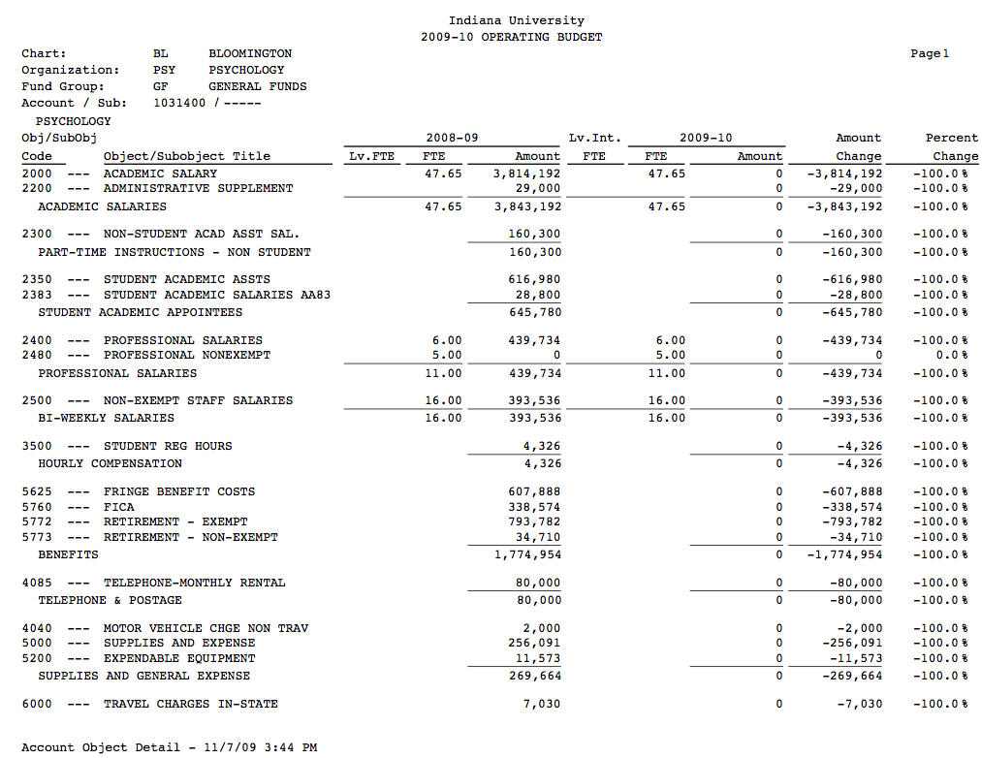

##### Account Salary Detail Report

The Account Salary Detail report contains information from the salary setting expansion screens associated with the currently open Budget Construction Document.

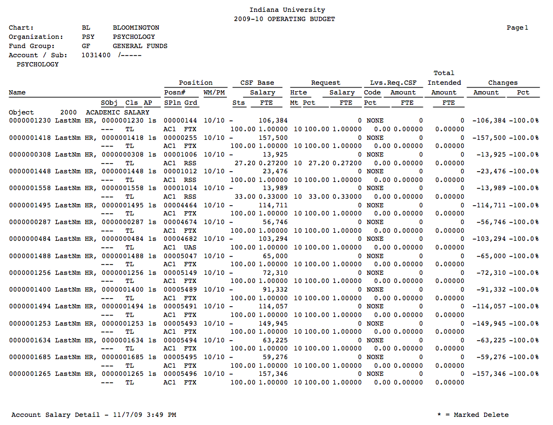

##### Account Monthly Detail Report

The Account Monthly Detail report contains monthly budget information associated with the currently open Budget Construction Document.

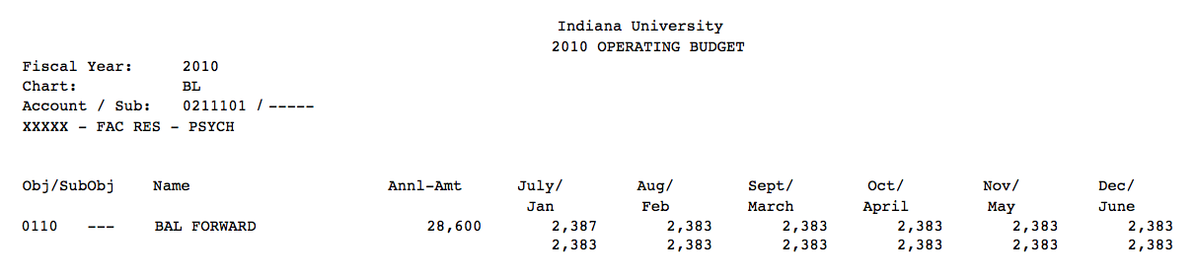

#### Organization Report Samples

##### Organization Account Funding Detail Report

The Account Funding Detail report prints the account salary report for each account that maps (either directly or indirectly) to the selected organization(s). As for other compensation reports, you may select the object codes to include in the report. The report prints by sub-fund by account. The Account Funding Detail report function displays a Salary Object List Selection screen that you must complete before you can submit the report.

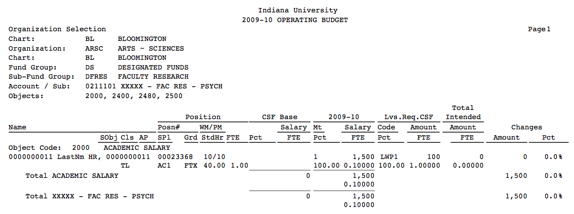

##### Organization Account Object Detail Report

|  |
| --- |
|  |

The Organization Account Object Detail report provides the same detail as the Object Summary report, except that the report prints each account that reports to the selected organization (in account number order) on an individual report. The report format is identical to the account-oriented Account Object Detail report described earlier.

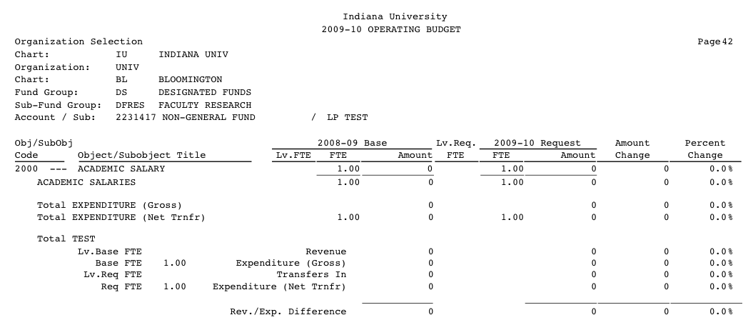

##### Account Summary Report

|  |  |  |
| --- | --- | --- |
|  |  |  |

The Account Summary Report lists the base and request budgeted revenues and expenditure totals, amount change and percent change by account for each account reporting either directly or indirectly to the selected organization. A separate report is produced for each organization selected. A total revenue and expenditure amount for the selected sub-fund is printed at the end of the report. If multiple sub-funds are selected, a separate report is produced for each selection. The consolidated option is available in this report. You must select sub-funds before submitting the report:

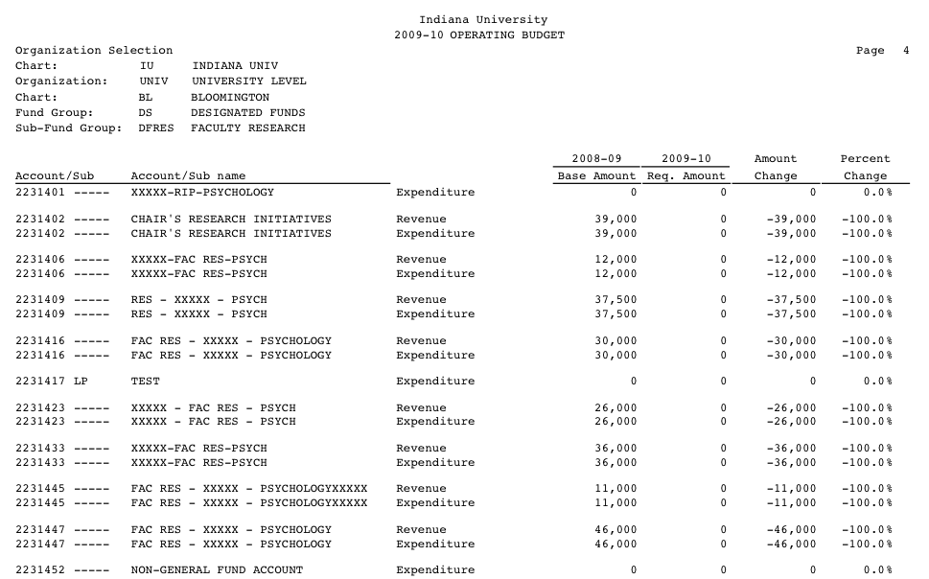

##### Level Summary Report

|  |  |  |
| --- | --- | --- |
|  |  |  |

The Level Summary Report sums, across all accounts reporting either directly or indirectly to the selected organization(s), revenue and expenditure totals by level. Also provided are the related FTE, amount change and percent change for each item on the report. Subtotals by consolidation are included in the report, as well as overall organization revenue, expenditure and difference totals. Each selected organization and sub-fund is printed as a separate report. You must select sub-funds from the Sub-Fund List Selection screen.

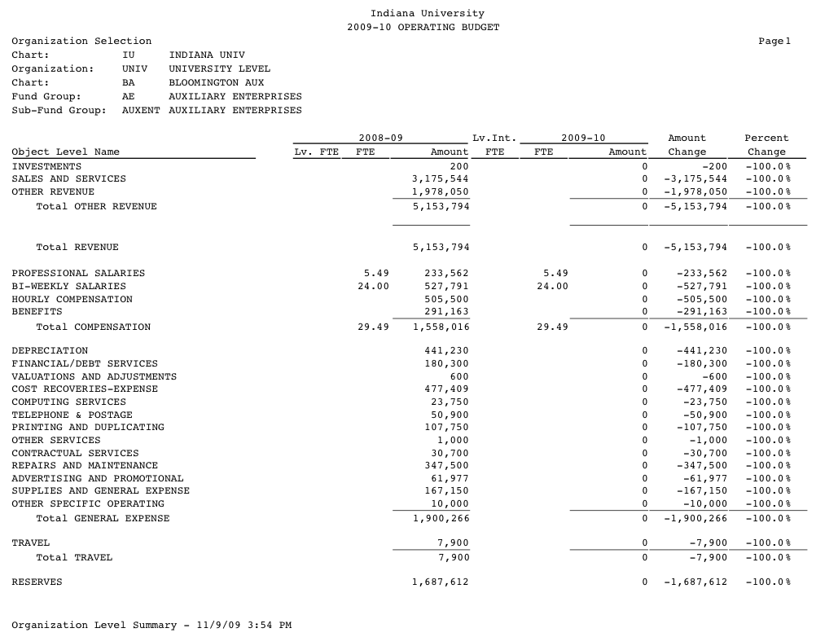

##### List 2PLG Report

|  |  |  |
| --- | --- | --- |
|  |  |  |

The BC Organization List 2PLG report contains any Budget Construction Documents (accounts) that contain the special accounting line using the 2PLG object code for the organization(s) selected.

Budget Construction Document accounting lines using the 2PLG object code are inserted/updated when a user adjusts the request amount for at least one of the document's detail salary lines using either of the detail salary setting screens.

After all changes resulting in '2PLG' entries are complete, the user runs this report and opens each account in turn to perform cleanup work.

pencil-small If the budget currently being built has not been balanced yet, the cleanup consists of simply removing the 2PLG accounting lines. Otherwise, the cleanup involves adjusting another accounting line to account for the change and then removing the '2PLG' accounting line. Examples of accounting lines used in '2PLG' adjustments include those representing pools of salary reserves, salary savings or transfers of revenue.

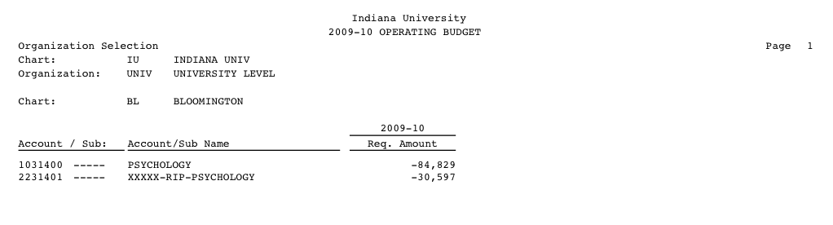

##### Monthly Object Summary

|  |  |  |
| --- | --- | --- |
|  |  |  |

The Monthly Object Summary Report provides a listing, by object code across all accounts reporting to the selected organization, of the annual total and the detailed monthly breakdown of request budget amounts. The sort on this report is the same as the sort on the Object Summary report described next.

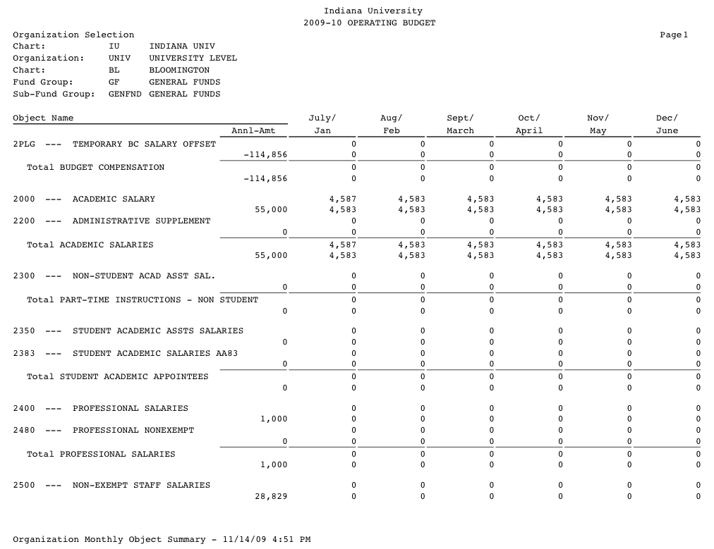

##### Object Summary Report

|  |  |
| --- | --- |
|  |  |

The Object Summary Report provides the same information as the Level Summary Report described above, by object code total rather than by object level. Object code totals are summed by object level and object consolidation as defined for each chart, in a manner similar to the standard operating reports produced and distributed by FMS on a monthly basis. Again, each selected organization and sub-fund is printed as a separate report.

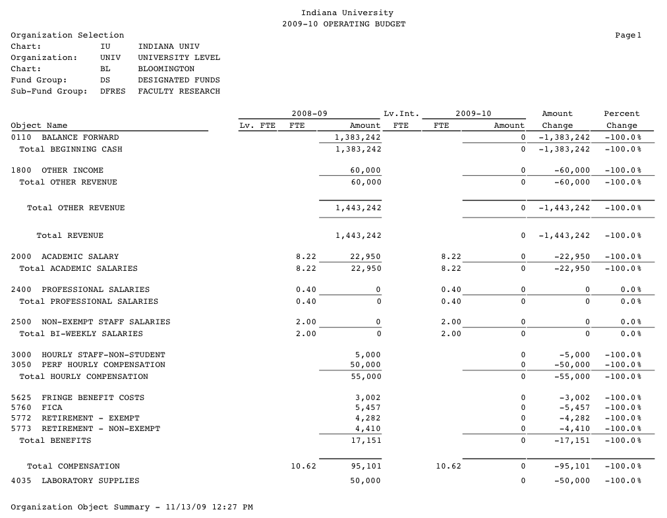

##### Payroll Synchronization Problem

|  |  |  |
| --- | --- | --- |
|  |  |  |

The BC Organization Synchronization Problems report contains any Budget Construction Documents (accounts) in which at least one detail funding line is flagged for synchronization problems for the organization(s) selected. The report is created in PDF format and sent to a new browser window in your local environment. You then have the option of saving or printing the PDF file.

A Budget Construction Document detail funding line is listed on the report when one or both of the problem flags are set. The Default Object Changed flag means that the default object code in the associated position has changed. The Position FTE Changed flag means that one of the constituent fields involved in the funded FTE calculation for the associated position has changed. Both of these situations require further investigation to verify that the funding line is still properly defined.

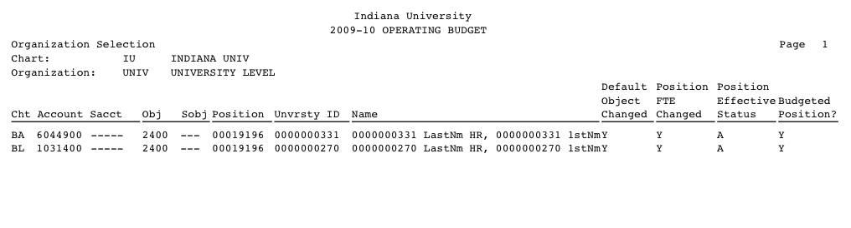

exclaim The process that actually sets the problem flags is not defined in the standard Kuali Financials Budget Construction module. Each implementing institution must build its own version of the perimeter service that handles the synchronization process between Budget Construction and the Payroll/HR system.

exclaim Resetting the problem flags is accomplished by using the Salary Setting by Position screen and clicking the **recalculate** button that is displayed at the bottom of the screen and fixing any problems related to displayed error messages. The button is displayed only when at least one of the flags is set.

##### Position Funding

|  |  |  |
| --- | --- | --- |
|  |  |  |

The Position Funding report provides CSF and request salary data for both filled and vacant positions for each position reporting either directly or indirectly to an organization. The positions are listed in alphabetic order by incumbent, displaying for each incumbent all funding sources in both the CSF and request areas, including the chart, account, sub-account, object and sub-object to which that funding line is attached. Complete position data are included (position number, rank code, effective and pay months, percent time and FTE); as well as CSF amount, percent time and FTE; request amount, effective months, percent time and FTE; leaves requested code, amount, percent time and FTE; total intended amount and FTE; and amount and percent change from CSF to request. The report is printed individually for each object code selected.

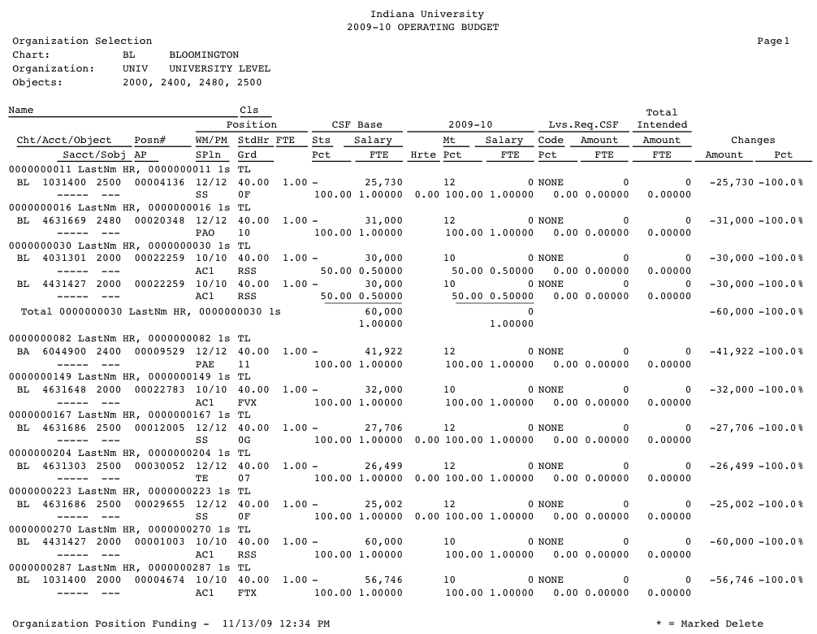

##### Reason Statistics

|  |  |  |
| --- | --- | --- |
|  |  |  |

The BC Organization Reason Statistics report displays the summary totals for funding-related information associated with the organization selection. summary totals are also provided on the [BC Organization Reason Summary report](https://test.kuali.org/confluence/display/KULDOC/BCOrg+Reason+Sum+Report) on the last page of each selected organization. This report allows the user to produce the summary totals without having to print the supporting detail.

The user has the option of filtering the information included on the final report using a comparison of CSF and request amounts and using a determined threshold. The comparison restates the CSF (base) amount to account for changes in position information related to the calculated FTE and uses the percentage change in the amounts as the basis for the filter.

Defining threshold criteria causes the Reason Code Selection screen to be skipped, resulting in a report containing all incumbents filtered by object code and threshold criteria regardless of funding marked by reason codes. This allows you to check for incumbent funding with missing reasons.

pencil-small Running the report with threshold criteria set implies that the reason code information displayed in the report may be blank for some incumbents. In this case, it is better to run the Reason Summary report to show those incumbents that are missing a reason code annotation to explain situations that reflect guideline exceptions.

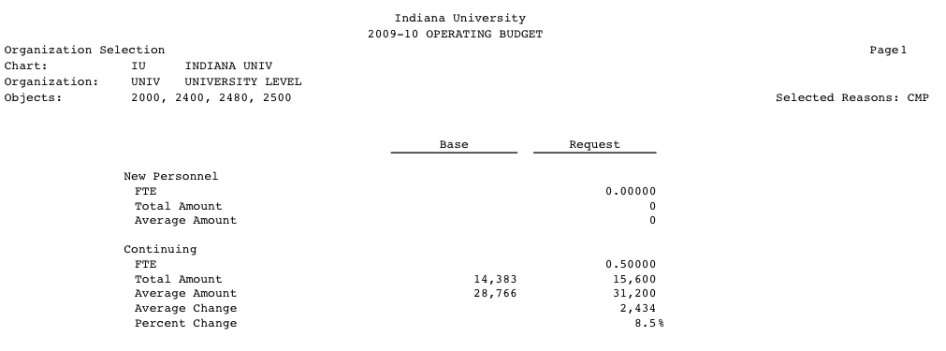

##### Reason Summary

|  |  |  |
| --- | --- | --- |
|  |  |  |

This report displays the summary totals for funding-related information associated with the organization selection. It also displays detail information for the selection.

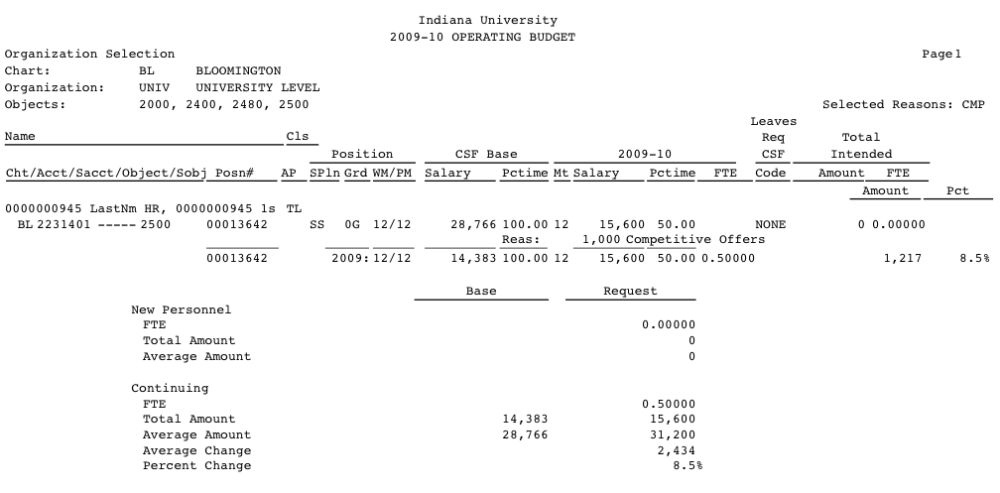

##### Salary Statistics

|  |  |  |
| --- | --- | --- |
|  |  |  |

This report displays summary totals for funding-related information associated with the organization selection.

The report consolidates the totals for the set of object codes selected. The summary totals include base and request statistical information for both new and continuing personnel: the total FTE, total amount and average amount, as well as the calculated average change and percent change from CSF to request. Summary totals are also provided on the BC Organization Summary report on the last page of each selected organization. This report allows you to produce summary totals without having to print the supporting detail.

##### Organization Salary Summary

|  |  |  |
| --- | --- | --- |
|  |  |  |

The BC Organization Salary Summary report displays funding-related information for each incumbent, position, account, sub-account, salary object code, and sub-object code associated with the organization selection. The report is created in PDF format and sent to a new browser window in your local environment. You then have the option of saving or printing the PDF file.

The Salary Summary report provides similar information as described above for the Position Funding Report, except only filled positions are included in the report. In cases where the request FTE is different than the CSF FTE for a continuing appointment, the report restates the CSF FTE as if the position had the same percent time and effective months as are assigned to the request FTE for that position, so that an accurate amount and percent change figure can be calculated and displayed.

The funding-related information includes information about the incumbent, position, administrative post, CSF, request, leaves request and total intended. The report is filtered by salary object code.

You also have the option of filtering the information included on the final report using a comparison of CSF and request amounts and using a determined threshold. The comparison restates the CSF (base) amount to account for changes in position information related to the calculated FTE and uses the percentage change in the amounts as the basis for the filter.

A report is printed for each object code selected. It contains a summary statistics section at the end of the report that summarizes for both new and continuing personnel the total base and request FTE, amount, and average, as well as the calculated average and percent change from CSF to request.

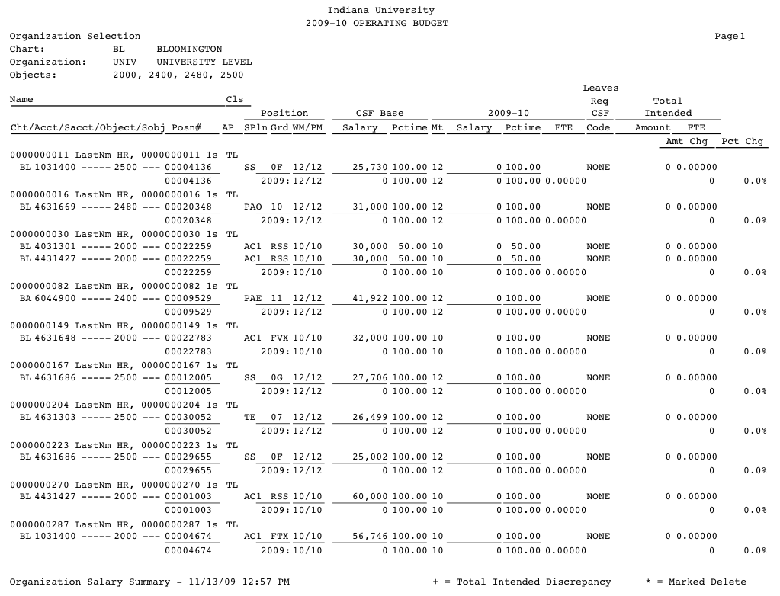

##### Sub-Fund Summary

|  |  |  |
| --- | --- | --- |
|  |  |  |

The BC Organization Sub-Fund Summary report summarizes the annual base and request for each sub-fund associated with the organization selection.

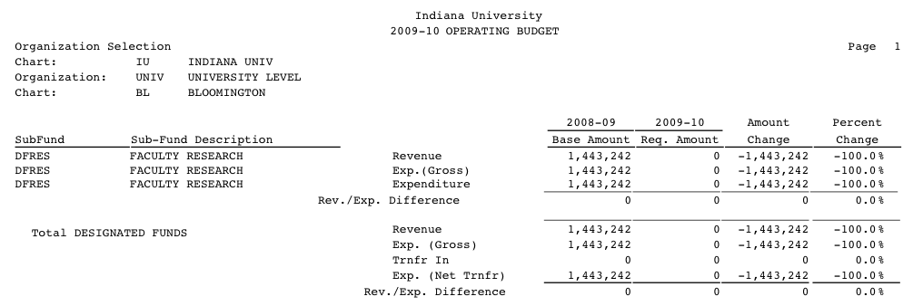

#### Account / Organization Export

|  |  |  |
| --- | --- | --- |
|  |  |  |

The BC Organization/Account Budget Document Data Export is a tool used to export denormalized budget document data. You choose one of three groupings of data. The data groupings are revenue/expenditure annual, detail salary annual, and revenue/expenditure monthly.

The tool can be used to export data for one or more Budget document(s), constrained by the Budget Construction security model. That is, export data can be accessed only if the associated document (budgeted account) is at or below your approval point of view.

The Sub-Fund Selection screen is available for organization access.

##### Budgeted Revenue/Expenditure Export

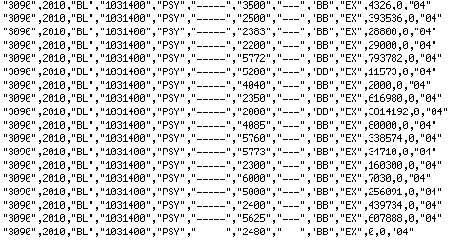

##### Budgeted Salary Lines Export

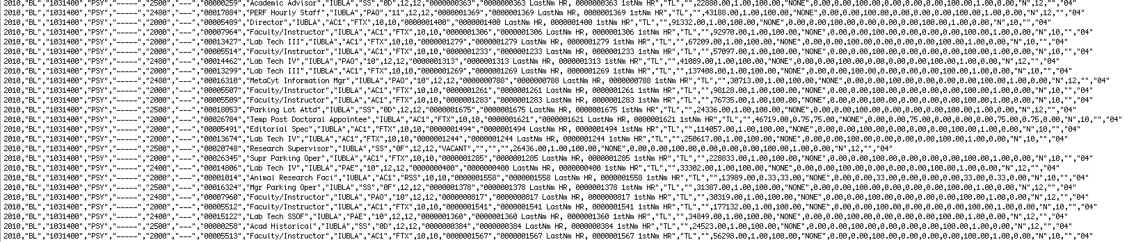

##### Monthly Budget Export



## Budget Construction Attribute Maintenance Documents

Budget Construction Attribute Maintenance documents

|  |  |  |
| --- | --- | --- |
| Document | Description | |
| Account Reports|tag=Account_Reports1 | Allows you to look up, create, and modify existing account reports, which map each account to its reporting organization for the fiscal year currently being budgeted. |
| Appointment Funding Duration | Allows you to look up, create, and modify existing duration codes, which are used in the Budget Construction Salary Setting process to identify the duration of leaves from work (sabbaticals, leaves without pay, etc). |
| Appointment Funding Reason Code | Allows you to look up, create, and modify existing reason codes, which are used in the Budget Construction Salary Setting process to indicate the reason for a particular salary increase. |
| Budget Construction Position | Allows you to view position information. If your institution chooses not to feed position information automatically from an external payroll system, also allows you to look up, create, and modify existing positions included in a budget. |
| Calculated Salary Foundation Tracker Override | Allows you to look up, create, and modify existing overrides that supersede data contained in the Labor Distribution Calculated Salary Foundation Tracker table. Overrides are applied from CSF Tracker Override to CSF Tracker as the last step in the process that updates CSF Tracker. |
| Fiscal Year Function Control | Defines whether a given function control code is active for a specific fiscal year. Used in the Budget Construction module. | |
| Function Control Code | Defines the different types of financial system function control codes that may be activated for a given fiscal year on the Fiscal Year Function Control table. Used in the Budget Construction module. | |
| Intended Incumbent | Allows you to view incumbent information. If your institution chooses not to feed incumbent information automatically from an external payroll system, also allows you to look up, create, and modify existing incumbents included in a budget. |
| Organization Reports | Allows you to look up, create, and modify existing Organization Reports documents, which map each organization to its reporting organization for the fiscal year currently being budgeted. |

### Account Reports|linktag=Account_Reports_Attribute_Maintenance

The Budget Construction Account Reports table contains the mappings of each account to its reporting organization for the fiscal year currently being budgeted. The table is initialized by the Genesis batch process from the Account table. The set of accounts is then maintained manually to reflect the organization structure for the coming fiscal year. These mappings may be different from the mappings in the current fiscal year chart tables, thereby allowing for planning and implementation of a reorganization.

#### Document Layout

Account Reports field definitions

|  |  |
| --- | --- |
| Title | Description |
| Account Number | The account number for a pool of funds to be reported. |
| Chart Code | The Chart of Accounts for an account to be reported. |
| Reports To Chart | Required. The chart for the reports-to organization for the account to be reported. Existing charts may be retrieved from the lookup icon. |
| Reports To Organization | Required. The reports-to organization for the account to be reported. Existing organizations may be retrieved from the lookup icon. |

#### Business Rules

* All fields must be filled in.
* **Chart** and **Account** must be valid in the Chart Account table.
* The Reports-to Chart and Organization must be valid in the Budget Construction Organization Reports table.

#### Example

The University of Kuali needs to track expenses associated with a new service provided in the current fiscal year by existing organization A. The new service will then be taken over by organization B in the next fiscal year. The expenses will be tracked using the new account 123.

A maintenance user for Organization A uses a Chart Account maintenance document to create the account 123 and assign Organization A as the Organization code.

Assuming the Budget Construction Genesis process has been previously run to initialize the next year's budget, Organization B uses a Budget Construction Account Reports maintenance document to create a new mapping for the account 123 and assign the Reports To Organization as Organization B. If the Budget Construction Genesis process has *not* yet run to initialize the next year's budget, Organization B must wait for the process to run; then it uses a Budget Construction Account Reports maintenance document to edit the existing mapping for the account 123 and assign the Reports To Organization B.

### Appointment Funding Duration

Duration codes are used in the Budget Construction Salary Setting process to identify the duration of leaves from work (sabbaticals, leaves without pay, etc). Some of the duration codes delivered with Kuali Financials include Sabbatical Leaves and Leaves Without Pay (for example: SAB1 - Sabbatical Leave: 1st Semester).

#### Document Layout

Appointment Funding Duration field definitions

|  |  |
| --- | --- |
| Title | Description |
| Active Indicator | Indicates whether this appointment duration code is active or inactive. Remove the check mark to deactivate this code. |
| Appointment Duration Code | A unique code that identifies the appointment duration of a leave of absence for a salary. |
| Appointment Duration Description | Required. A description of the appointment duration code, which usually includes a description of the type and duration of the leave of absence.  Example: Sabbatical Leave: 1st Semester. |

#### Business Rules

* All fields must be filled in.
* The system forces the **Duration Code** to be uppercase.
* The system forces the **Duration Description** to be uppercase.

#### Example

The University of Kuali has a group of employees that can potentially take a leave of absence without pay for a period of nine months. The university wants to track this type of leave in the base budget. A maintenance user for the University uses a Budget Construction Appointment Funding Duration maintenance document to create a new duration type, entering Appointment Duration Code 'LWP9' and Appointment Duration description 'LWOP: 9 months.'

### Appointment Funding Reason Code

Appointment Funding Reason Codes are used in the Budget Construction Salary Setting process to indicate the reason for a particular salary increase.

#### Document Layout

Appointment Funding Reason Code field definitions

|  |  |
| --- | --- |
| Title | Description |
| Active Indicator | Indicates whether this appointment funding reason code is active or inactive. Remove the check mark to deactivate this code. |
| Appointment Funding Reason Code | The reason code for a requested salary appointment funding. |
| Appointment Funding Reason Description | Required. The description of the appointment funding reason code. |

#### Business Rules

* All fields must be filled in.
* The system forces the reason code to be uppercase.
* You cannot deactivate a reason code that is currently in use in **Salary Setting** in the Budget Construction Appointment Funding Reason table.

#### Example

The University of Kuali needs to track all employees in Budget Construction Salary Setting that get a raise outside of normal salary increase guidelines due to a special set of circumstances called 'Blue Square Employee.'

A maintenance user for the University uses a Budget Construction Appointment Funding Reason Code maintenance document to create a new reason code, entering **Appointment Funding Reason Code** 'BSE' and **Appointment Funding Reason** description 'Blue Square Employee.'

### Budget Construction Position

The Budget Construction Position table contains information usually found in the institution's HR/Payroll system. A position is usually defined as a specific post of employment or an entity that describes a collection of duties associated with a specific job code.

If the system parameter (EXTERNAL_POSITION_FEED_IND = 'N') is set to not feed position information from an external system, you also have the option of creating new positions and modifying existing positions.

pencil-small If the system parameter EXTERNAL_POSITION_FEED_IND = 'Y', the Budget Construction Position maintenance functions are disabled, and Budget Construction position maintenance is handled by the external system.

#### Document Layout

Budget Construction Position field definitions

|  |  |
| --- | --- |
| Title | Description |
| Budgeted Position | Required. Indicates whether the position is marked as budgeted or non-budgeted. Check the box if the position is budgeted.  exclaim The system displays an error if you try to add or update and save active BC appointment funding rows (LD_PNDBC_APPTFND_T) for non-budgeted positions. |
| Confidential Position | Indicates whether the position is associated with a union so the batch union salary setting process can be handled differently.  'N' = Include the row in the union export file.  'Y' = Do not include the row. |
| Default Object Code | Required. The default object code for the position.  exclaim Budget Construction compares this value to the object code in each of the associated active appointment funding rows and produces an error message if they are different. |
| Department Set ID | The department set ID for the position. This value qualifies a set of departments as identified by the position department identifier. |
| Job Code | An alphanumeric code representing the job code for the position. Job codes are used to define groups of positions. |
| Job Code Description | A written description of the job code. |
| Job Code Set ID | The job code set ID for the position. This value qualifies the set of job codes. |
| Normal Work Months | Required. The number of months an incumbent in this position will normally work in a year. Budget Construction uses this value as a constituent part of the appointment funding FTE calculations.  exclaim This value is compared to the funding months in each of the associated active appointment funding rows and an error message is produced if they are different. |
| Pay Months | Required. The number of months during the year an incumbent filling the position gets a paycheck. Budget Construction uses this value as a constituent part of the appointment funding FTE calculations. |
| Position Department Identifier | Required. The department ID for the position.  The department ID can be a concatenation of the chart and organization that owns the position. The system uses the value as part of the position lookup search criteria. |
| Position Description | Required. A description of the position. Budget Construction displays this value and uses it as part of the position lookup search criteria. |
| Position Effective Date | The date that the position information in this row becomes effective. |
| Position Effective Status | Required. Select your option from the list. Options are  A = Active  I = Inactive |
| Position Full Time Equivalency | The full time equivalent value for the position. This value is usually derived by using the formula:  (**Position Standard Hours Default** / 40) * (**Normal Work Months** / **Pay Months**).  exclaim Budget Construction compares this value with the total FTE in the active appointment funding rows and warns the user if the values are different. |
| Position Number | The position number for this position. This value combined with the university fiscal year identify the position. |
| Position Regular Temporary | A flag that indicates whether the position is regular or temporary. Use the list to select the appropriate value. |
| Position Salary Grade Default | Required. The default salary grade for the position. Budget Construction uses this value as part of the position lookup search criteria. |
| Position Salary Plan Default | Required. The default salary plan for the position. Budget Construction uses this value as part of the position lookup search criteria. |
| Position Standard Hours Default | Required. The standard number of hours an incumbent in this position will work in a week. The system's standard hours default for the position. Budget Construction compares the total percent time in the active appointment funding rows converted to hours and warns you if the values are different. |
| Position Status | Select the status of this position from the list. Sample values you may use include:  A = Approved  D = Deleted  F = Frozen  T = Terminated |
| Position Type | Required. The position type for the position. Example values to use could be:  AC = Academic  SB = Staff Bi-Weekly  SM = Staff Monthly  Budget Construction uses the value as part of the position lookup search criteria. |
| Position Union Code | If position is union-affiliated, associates it with a union code. |
| Responsibility Center Code | Required. The responsibility center code for the position. The responsibility center code value is usually derived from the BC Organization Reports To table using the POS_DEPTID value to identify the organization. Budget Construction uses the value as part of the position lookup search criteria. |
| Salary Set ID | The salary set ID for the position. This value qualifies the set of default administration plans and grades. |
| University Fiscal Year | The university fiscal year. Existing fiscal years may be retrieved from the lookup icon.  This value combined with the position number identify the position. |

#### Business Rules

* Fields marked required must be filled in.
* The set of required fields for a position can be relaxed, but the minimum set must include **Position Number**, **University Fiscal Year**, **Position Description**, **Position Effective Status**, **Budgeted Position**, **Position Standard Hours Default**, **Position Full Time Equivalency**, **Normal Work Months**, **Pay Months**, and **Default Object Code**.
* The **Position Full Time Equivalency** field is calculated from other required field values.
* **Position Full Time Equivalency** = **Position Standard Hours Default**/40 * **Normal Work Months**/**Pay Months**
* Example: 0.50 = 20/40 * 12/12
* Example: 0.50 = 20/40 * 10/10
* Example: 1.00 = 40/40 * 12/12
* We recommend that the **Department ID** field be a concatenation of the **Chart of Accounts Code** and **Organization Code** values in the Chart Organization table (CA_ORG_T) and that validation be implemented by the implementing institution. Further, we recommend that the **Default Object** field value validation go against the Chart Object table (CA_OBJECT_CODE_T) using the **University Fiscal Year** field value and **Chart of Account Code** value from the **Department ID** field.

exclaim Any removal of fields from the set of required fields involved in the Salary Setting business rules requires disabling of the associated rule.

exclaim These rules may be mitigated if the position table is populated through a process built by the implementing institution.

#### Example

The University of Kuali’s system is not configured to feed position information from the University's payroll system (System Parameter 'EXTERNAL_POSITION_FEED_IND' is set to 'N'). (Feeding information from an external system means the local Position maintenance document is disabled and position maintenance is handled by the external system.)

Organization A at University of Kuali is planning to hire someone in the new fiscal year to perform tasks related to planning big fund raising events. This job in the organization (position) will be new in the coming year, and a budget for the salary needs to be created. A maintenance user for Organization A uses a Budget Construction Position maintenance document to create the new position. This enables the ability to fund the position as 'VACANT' in an account using Budget Construction Salary Setting.

### Calculated Salary Foundation Tracker Override

The Calculated Salary Foundation (CSF) Tracker Override table contains data that supersedes data contained in the Labor Distribution Calculated Salary Foundation Tracker table. Overrides are applied from CSF Tracker Override to CSF Tracker as the last step in the process that updates CSF Tracker.

#### Document Layout

Calculated Salary Foundation Tracker Override field definitions

|  |  |
| --- | --- |
| Title | Description |
| Account Number | Required. The account number for the override. Existing account numbers may be retrieved from the lookup icon. |
| Active Indicator | Required. Indicates whether this override is active or inactive. Remove the check mark to deactivate this override. |
| Chart Code | Required. The unique identifying code assigned to a chart for the override. Existing chart codes may be retrieved from the lookup icon.  C:\Users\jonny\Desktop\KFS 5.0.2\User Guide Images\pencil-small.gif When the parameter Accounts_Can_Cross_Charts is set to 'No', the system derives the chart code from the account number entered, and an entry in this field is not required. |
| CSF Amount | Required. The position CSF amount for the override. |
| CSF Delete Code | Required. The CSF delete code for the override. |
| CSF FTE | Required. The CSF full time equivalent value for the override. |
| CSF Funding Status Code | Required. The CSF funding status code for the override. |
| CSF Time Percent Time | Required. The CSF percent time value for the override. |
| Employee ID | Required. The employee ID for the override. Existing employee ID's may be retrieved from the lookup icon. |
| Object Code | Required. The object code for the override. Existing object codes may be retrieved from the lookup icon. |
| Position Number | Required. The position number for the override. |
| Sub-Account Number | Required. The sub-account number for the override. Existing sub account numbers may be retrieved from the lookup icon. |
| Sub-Object Code | Required. The sub-object code for the override. Existing sub object codes may be retrieved from the lookup icon. |
| University Fiscal Year | Required. The university fiscal year. Existing fiscal years may be retrieved from the lookup icon. |

#### Business Rules

* Fields marked required must be filled in.
* The **CSF Delete Code** entry can be null. The implementing institution must implement the validation for an appropriate value to mean delete.
* An active/inactive flag is used to indicate to the CSF Override process to apply active overrides only.
* The **Fiscal Year** entry must be the current fiscal year.
* The appointment must be valid, as defined by your institution.
* The position must be valid, as defined by your institution.

#### Example

The University of Kuali has designed and implemented a process (CSF process) that populates the Calculated Salary Foundation Tracker (CSFT) table using information contained in the institution's payroll system. Organization A at the University has found that one of its employees has a base salary amount in the Budget Construction Salary Setting system that incorrectly contains additional pay meant only as a one-time benefit.

Normally, these types of errors are due to incorrect data input to the Payroll system, and the fix is to correct the data there, in which case the next run of CSF produces the correct base salary amount. Instead, in the interest of time or other reason, the organization decides that the base salary amount in CSF needs to be overridden. A maintenance user for Organization A uses a Budget Construction Calculated Salary Foundation Tracker Override maintenance document to create an override row using appropriately matching accounting key values along with the correct base salary. The corrected base salary is placed into the CSFT table by the CSF process the next time it runs. The corrected base salary is also copied to Budget Construction by the nightly update portion of Genesis the next time it runs.

### Fiscal Year Function Control

The Fiscal Year Function Control document defines whether a given Function Control code is active for a specific fiscal year. These values determine whether certain actions related to budgets can be taken in the defined fiscal year.

#### Document Layout

Fiscal Year Function Control field definitions

|  |  |
| --- | --- |
| Title | Description |
| Financial System Function Active Indicator | Selection of this box activates the financial system function control code for the identified fiscal year. Removal of the check in this box deactivates the code. |
| Financial System Function Control Code | The financial system function control code being defined for the fiscal year. |
| University Fiscal Year | The fiscal year for which the function control code is being defined. |

### Function Control Code

The Function Control document defines the different types of Financial System Function Control codes that may be activated for a given fiscal year on the Fiscal Year Function Control table. Both Function Code and Fiscal Year Function Control manage functions in the Budget Construction Module.

Function Control Code definitions

|  |  |
| --- | --- |
| Code | Description |
| **BAACTV** | Indicates if the budget adjustment document is active for a fiscal year |
| **BASEAD** | Indicates if base budget adjustments can be performed for a fiscal year |
| **BCACTV** | Activates budget construction for a given year |
| **BCGENE** | Enables Kuali Financials to accept the budget construction genesis process |
| **BCUPDT** | Controls the ability to make updates to budget construction data when base budget changes are made with the Budget Adjustment document for the fiscal year that is the base for budget construction. |
| **BSSYNC** | Controls whether a payroll batch synchorization is allowed to run. |
| **CSFUPD** | Enables the updating of the calculated salary foundation (CSF). |
| **PSSYNC** | Enables Budget Construction to accept synchronization data from a payroll system for budget construction. |

#### Document Layout

Function Control Code field definitions

|  |  |
| --- | --- |
| Title | Description |
| Active Indicator | Indicates whether the intended incumbent is active or inactive. |
| Financial System Function Control Code | The code that uniquely identifies the function control value. |
| Financial System Function Default Indicator | Selection of this box indicates that the default value is active. Removal of the check in this box deactivates the code. |
| Financial System Function Description | The text description associated with the function control code. |

### Intended Incumbent

The Intended Incumbent table contains employee information usually found in the institution's HR/Payroll system.

If the system parameter (EXTERNAL_INCUMBENT_FEED_IND = 'N') is set to not feed incumbent information from an external system, you also have the option of creating new incumbents and modifying existing incumbents.

pencil-small.gif If the system parameter EXTERNAL_INCUMBENT_FEED_IND = 'Y', the BUDGET CONSTRUCTION Intended Incumbent maintenance functions are disabled, and intended incumbent maintenance is handled by the external system.

#### Document Layout

The Budget Construction Intended Incumbent document includes the **Edit BC Intended Incumbent** tab. With the exception of the **ID**, **Name**, and **Active Indicator** fields, the fields on this tab are meant to help users make salary setting decisions.

Intended Incumbent field definitions

|  |  |
| --- | --- |
| Title | Description |
| Employee ID | The employee ID. |
| Person Name | Required. The person's name. |
| Salary Set ID | The salary admin plan set identifier for the employee. This value qualifies the set of administration plans and grades. (Effectively, this is the same value used as the **Position Set ID Salary** for the employee's primary position.) |
| Salary Administration Plan | The salary administration plan code for the employee. (Effectively, this is the same value used as the **Position Salary Administration Plan Default** for the employee's primary position.) |
| Salary Grade | The salary administration grade code for the employee. Effectively, this is the same value used as the **Position Salary Administration Grade Default** for the employee's primary position. |
| IU Classification Level | The classification level for the employee. Classification level can be used to classify an employee as defined by your institution. For example, the level may be used to indicate who is a full professor and who is an associate professor. |

#### Business Rules

* **Employee ID** and **Person Name fields** must be filled in.
* These rules may be mitigated if the Incumbent table is populated through a process built by the implementing institution.

#### Example

The University of Kuali's system is not configured to feed intended incumbent information from the University's payroll system (System Parameter 'EXTERNAL_POSITION_FEED_IND' is set to 'N'.)

Organization A at University X is planning to hire someone in the new fiscal year to perform tasks related to planning big fund raising events. This job in the organization (position 321) already exists, but the newly hired person is not yet in the Budget Construction system and as such, needs to be funded from an account for the position. A maintenance user for Organization A uses a Budget Construction Intended Incumbent maintenance document to create the new incumbent. This enables the ability to fill position 321 with the new hire, funding it from an account using Budget Construction Salary Setting.

### Organization Reports

Each Organization Report document maps an organization to its reporting organization for the fiscal year currently being budgeted. Each document also maps the organization to a responsibility center through the Responsibility Center Code. These mappings may be different from what is found in the current fiscal year chart tables, thereby allowing for planning and implementation of a reorganization.

#### Document Layout

Organization Reports tab definition

|  |  |
| --- | --- |
| Title | Description |
| Chart Code | Required. Identifies the Chart of Accounts for the organization. |
| Organization Code | Required. The organization code for this organization. |
| Report To Chart | Required. The chart for the organization that this organization reports to. |
| Report To Organization | Required. The organization that this organization reports to. |
| Responsibility Center Code | Required. The code for the responsibility center that this organization belongs to. |

#### Business Rules

* All fields must be filled in.
* **Chart** and **Organization** must be valid in the Chart Organization table.
* The **Reports to Chart** and **Reports to Organization** must be valid in the Budget Construction Organization Reports table.
* The **Reports to Chart** and **Reports to Organization** must reference a valid path to the root of the hierarchy tree with no infinite loops (cycles), except for the root.
* The **Responsibility Center Code** must be valid in the Chart Responsibility Center table.

#### Example

The University of Kuali needs to reorganize Organization A. It currently reports to Organization B, but it needs to report to Organization C starting with the next fiscal year. All accounts reporting to Organization A need to keep reporting to Organization A, but all accounting and reporting activities will now come under Organization C's control. The Budget Construction Genesis process has been previously run to initialize the next year budget, so a maintenance user uses a Budget Construction Organization Reports maintenance document to update the reports-to organization mapping for Organization A, changing the Reports To Organization from Organization B to Organization C. The responsibility center code may also need to be updated to be the same value used by Organization C. Any organizations reporting to Organization A may also need the Responsibility Center Code adjusted.

## Budget Construction Batch Processes

BC Batch Jobs

|  |  |
| --- | --- |
| Job Name | Description |
| Budget Construction General Ledger Load Batch Job | Posts transactions into the General Ledger Pending table for processing in the next nightly batch cycle. It should be run after the Budget Construction process is complete.  C:\Users\jonny\Desktop\KFS 5.0.2\User Guide Images\pencil-small.gif No separate batch job exists for extracting immediate Disbursement Voucher payments to PDP because these payments are automatically extracted into PDP when the immediate DV reaches FINAL or PROCESSED status or when the Disbursement Manager clicks the Extract Now button on a DV that was not selected for immediate payment prior to extraction. |
| Budget Construction Update Job | Updates or creates new Budget Construction documents based on the Fiscal Year Function Control codes: BCUPDT, CSFUPD, BSSYNC and PSSYNC. |
| Genesis Batch Job | Creates Budget Construction documents based on data contained in the General Ledger or CSF Table.  exclaim The Fiscal Year Makers job must be run prior to Genesis because Genesis needs next year tables in order to create the Budget Construction documents. |